.Create user with name Techie and provide sudo access to user.
To create a user named Techie and grant them administrative privileges log in as the root user (or an existing admin) and run sudo adduser Techie followed by sudo usermod -aG sudo Techie (on Ubuntu/Debian) or sudo usermod -aG wheel Techie (on CentOS/RHEL).
The complete step-by-step setup process varies slightly depending on your Linux distribution:
Ubuntu or Debian Systems
On Debian-based systems like Ubuntu and Linux Mint the administrative group is named sudo.
- Create the user
example:
sudo adduser Techie
Follow the terminal prompts to set a secure password and enter optional user details.
- Add the user to the sudo group
example:
sudo usermod -aG sudo Techie
The -aG flags ensure you append the user to the group without removing them from their existing groups.

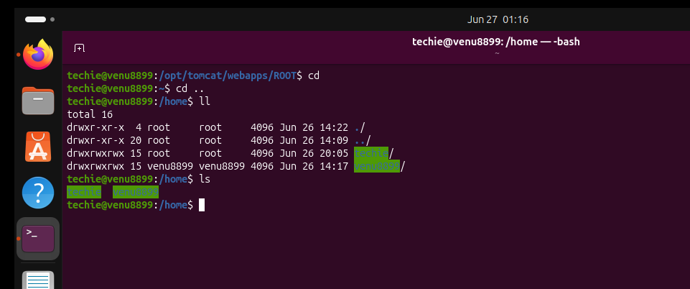
. Navigate to the home directory.
To navigate directly to your home directory in Linux type cd into your terminal and press Enter.
Quick Methods to Jump Home
- cd - The easiest way; running it without arguments defaults to your home path.
- cd ~ - Uses the tilde (~) symbol which is the shell shortcut for home.
- cd $HOME - Uses the environment variable that points to your home directory.
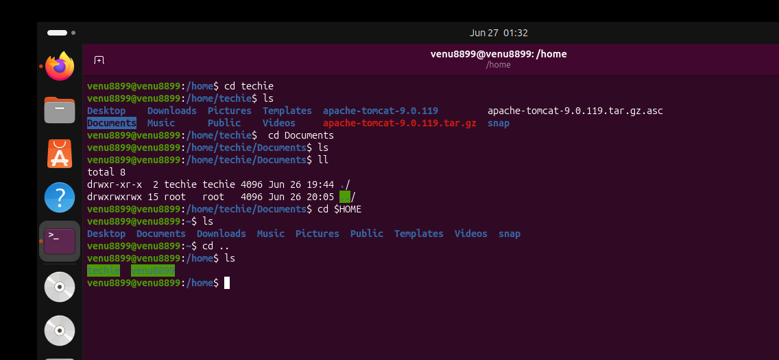

. Create a new directory.
To create a new directory in Linux use the mkdir command followed by the name of your folder.
Example: mkdir file/folder/directory name
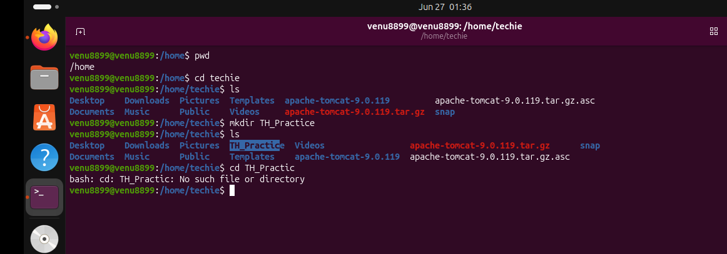

.List the contents of a directory.
To list the contents of a directory in Linux use the ls command which stands for "list". By default running ls on its own will list all visible files and folders in your current working directory.
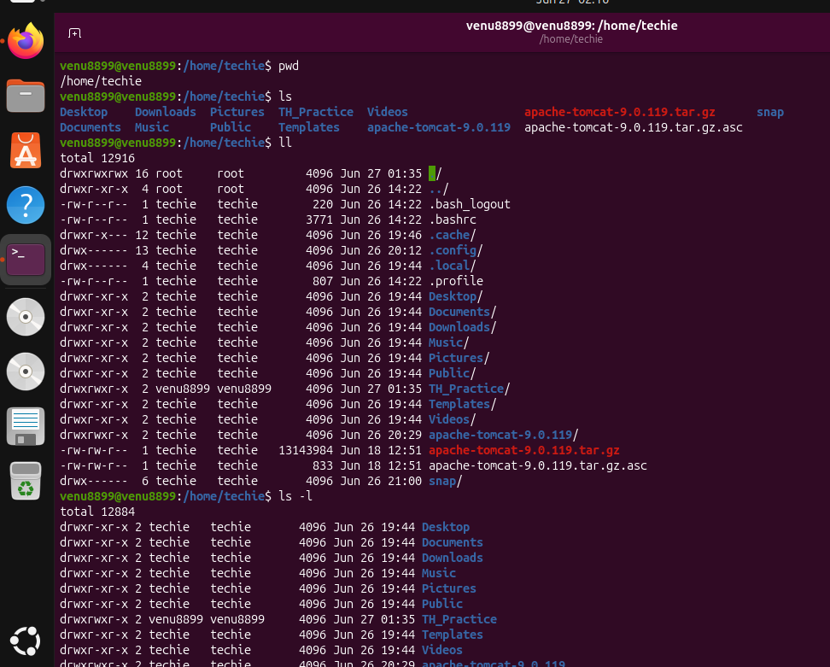

. Change the current directory.
To change the current working directory in Linux use the cd command followed by the path of the directory you want to enter. For example typing cd Documents will instantly move your terminal session into your "Documents" folder.
Quick Shortcuts
- Move up one level: cd ..
- Go to your home folder: cd ~ (or simply cd with no arguments)
- Go to the root directory: cd /
- Return to your previous directory: cd –
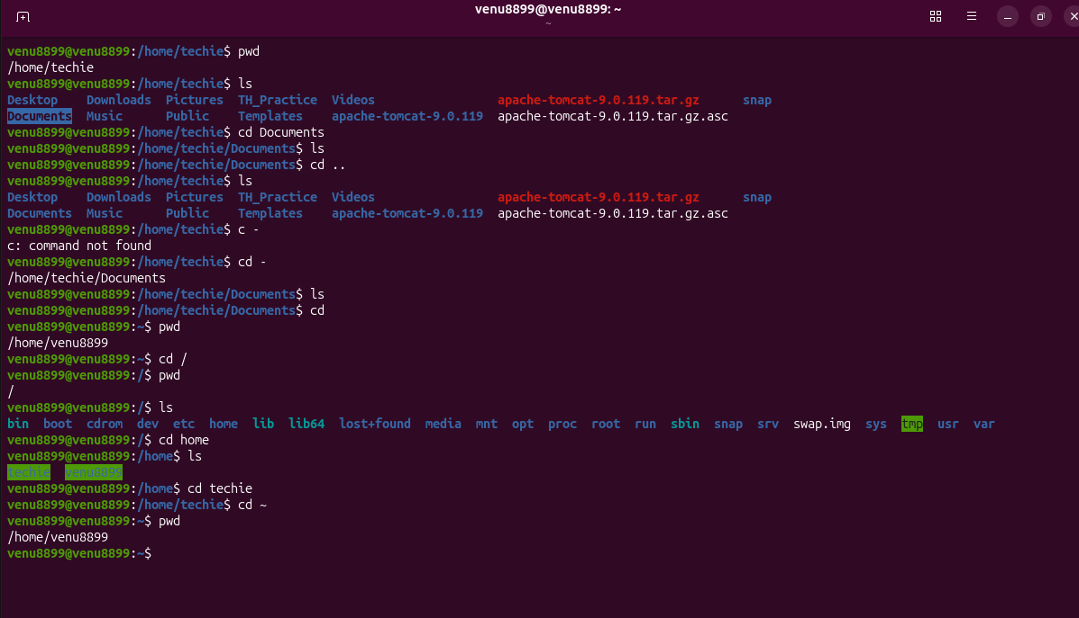

.Create a new empty file.
To create a new empty file in Linux the most common and efficient method is using the touch command.
Method : Using the touch Command
The standard way to quickly generate an empty file is by typing touch followed by your desired filename.

touch filename.txt

- How it works: If the file does not exist touch creates it immediately. If it already exists touch safely updates its last modified timestamp without changing or wiping out any of its content.
- Multiple files: You can also create several empty files at the same time by separating the names with spaces:

touch file.txt file.txt file.log
Method : Using the Redirection Operator (>)
You can use a standard shell redirection operator to create an empty file. This tells the command line to pipe an empty output into a new filename.

> filename.txt

- Warning: If a file with that name already exists this method will instantly truncate (wipe clean) all the existing content inside it.
Method : Using the Null Command (:)
For automated environments like Bash scripts you can pair the null command : with the redirection operator.

: > filename.txt

- Why use it: This operates similarly to Method but is often preferred in scripts because it cleanly guarantees a successful exit code.
Verification
To confirm that your file was successfully created with a size of zero bytes list the directory contents using the Linux reference format:

ls -l filename.txt
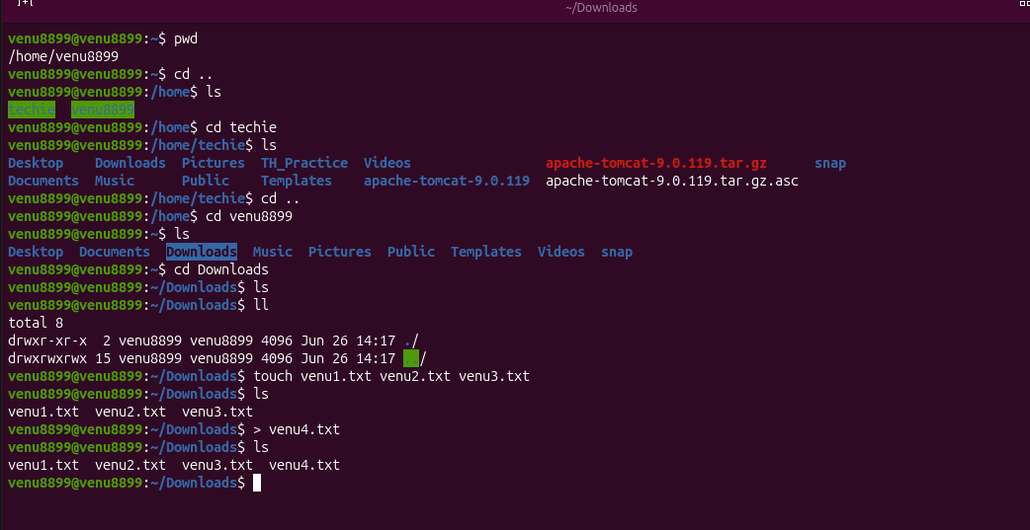

write to a file in linux:
You can write to a text file in the Linux terminal using either quick terminal commands for short snippets or text editors for full document editing.

Method : Using Quick Commands (Best for small edits)
You can write directly to a file using the echo command combined with redirection operators (> or >>).
- To create or overwrite a file: Use a single > operator.

echo "This is my text" > filename.txt

- To append text without overwriting: Use a double >> operator.

echo "This is an additional line" >> filename.txt

You can also use the cat command to type multiple lines of text directly into the terminal interface:
- Type cat > filename.txt and press Enter.
- Type out all your text lines.
- Press Ctrl + D on your keyboard to save and close the file.
Method : Using Terminal Text Editors (Best for full files)
If you need a more traditional word-processor-style interface within your terminal window you can use built-in text editors.
Nano (Easiest for beginners)
- Open the file by running:

nano filename.txt

- Type your text directly into the screen interface.
- Press Ctrl + O then Enter to save the changes.
- Press Ctrl + X to exit back to the command prompt.
Vim (Advanced)
- Open the file by running:

vim filename.txt

- Press the i key to enter Insert Mode so you can start typing text.
- When finished press the Esc key to exit Insert Mode.
- Type :wq and press Enter to save (write) and quit the program
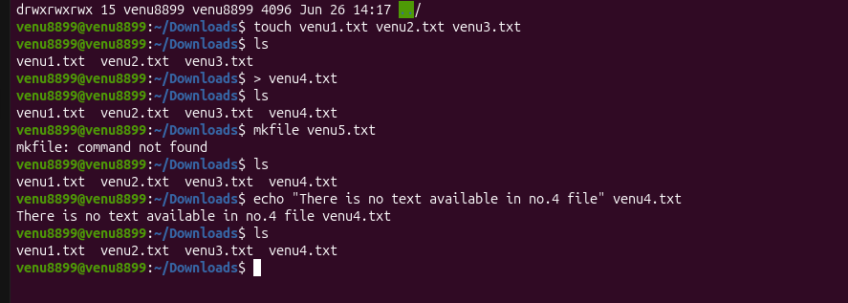

. View the contents of a file.
To view the contents of a file in Linux you can use several terminal commands depending on the size of the file and how you want to read it. The standard most common commands are cat for short files and less for large files.

Standard Commands
- cat filename.txt
Prints the entire content of the file directly onto your terminal screen. It is best suited for short files. You can review discussions on its usage on Super User.
- less filename.txt
Opens the file in a scrollable interactive pager interface. This is perfect for long files because it does not load the entire file into memory at once.
  - Use Arrow Keys or Spacebar to scroll.
  - Type /keyword to search forward for a specific term.
  - Press q to exit the view and return to the terminal prompt.
Viewing Specific Portions
- head filename.txt
Displays the first lines of a file by default. You can change the line count using the -n flag (e.g. head -n filename.txt).
- tail filename.txt
Displays the last lines of a file by default.
- tail -f filename.txt
Monitors a file in real-time. It automatically outputs new lines as they are appended to the file which makes it ideal for watching live log data.
Interactive Text Editors
If you also need to modify the file or navigate it using a full text-editor environment you can use pre-installed terminal editors:
- nano filename.txt (beginner-friendly with shortcut keys displayed at the bottom)
- vi filename.txt or vim filename.txt (advanced syntax-highlighted editor)

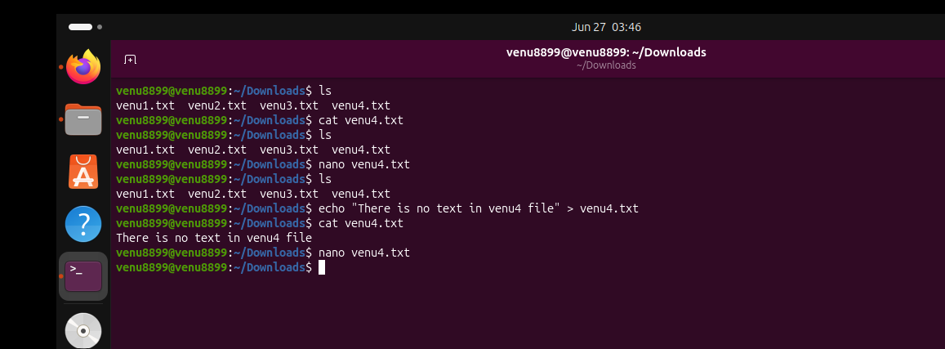

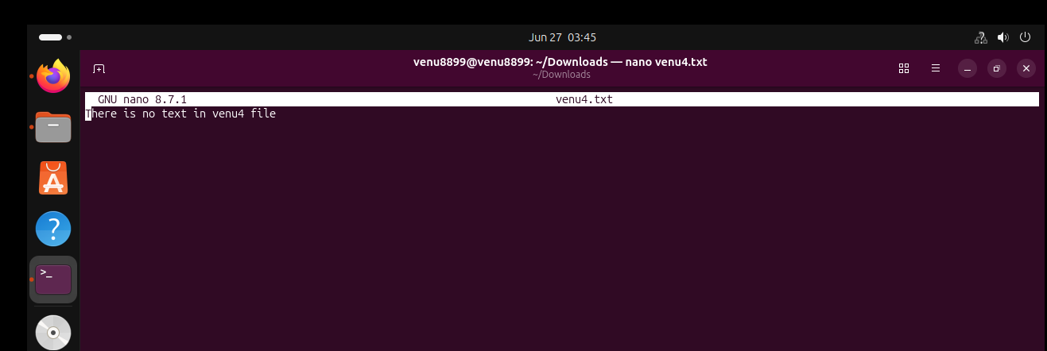

. Copy a file to another location.
To copy a file to another location in the Linux terminal use the cp command followed by the source file and the destination path.
The basic syntax is:

cp [options] source_file destination

Basic Copying Examples
- Copy a file into another directory (keeping the same name):

cp document.txt /home/user/Documents/

- Copy a file to another directory and rename it:

cp document.txt /home/user/Documents/backup_doc.txt

- Copy multiple files into a directory:

cp file.txt file.txt /home/user/Documents/

Useful Options
- Copy an entire directory: Use the -r (recursive) flag to copy a folder and all its contents.

cp -r /path/to/source_folder /path/to/destination_folder

- Prevent accidental overwriting: Use the -i (interactive) flag to prompt you for confirmation if a file with the same name already exists at the destination.

cp -i document.txt /home/user/Documents/

- Preserve file attributes: Use the -p flag to keep the original file permissions ownership and modification timestamps.

cp -p document.txt /home/user/Documents/
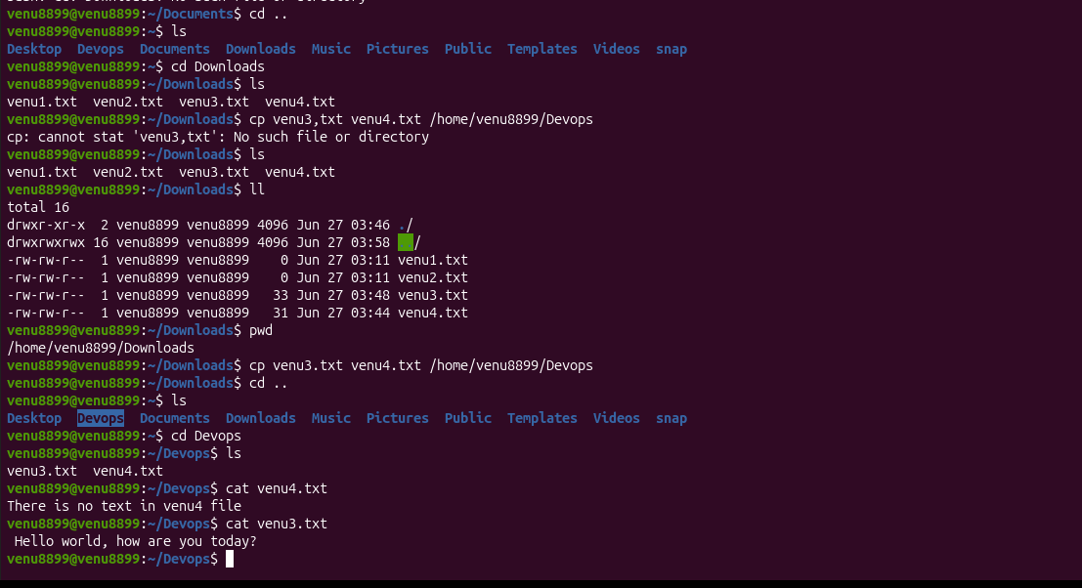

.Move a file to another location
To move a file in the Linux terminal use the mv command followed by the source file and the destination path.
Basic Usage
The standard syntax for the mv command is:

mv [source] [destination]

Here are the most common scenarios:
- Move to a specific folder: Keep the same file name but change its directory.

mv report.txt /home/user/Documents/

- Move and rename simultaneously: Relocate the file and assign it a new name at the destination.

mv report.txt /home/user/Documents/final_report.txt

- Move multiple files: List all the files you want to transfer followed by the destination directory as the final argument.

mv file.txt file.txt /home/user/Documents/

- Move files using wildcards: Move all files matching a specific pattern (e.g. all .txt files).

mv *.txt /home/user/Documents/

Useful Safety Flags
By default the mv command will overwrite any file with the same name at the destination without warning. You can use these flags to control that behavior:
- -i (Interactive): Prompts you for confirmation before overwriting an existing file.

mv -i report.txt /home/user/Documents/

- -n (No-clobber): Prevents the command from overwriting any existing file entirely.

mv -n report.txt /home/user/Documents/

- -v (Verbose): Displays the name of each file as it is being moved which is great for tracking large batches.

mv -v report.txt /home/user/Documents/

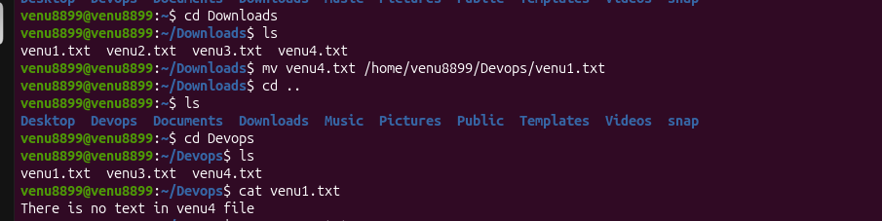

.Rename a file
To rename a file in Linux use the mv (move) command in your terminal. Linux does not have a dedicated "rename" command by default for single files; instead moving a file to the same location with a new name achieves the rename.
Rename a Single File
Use the mv command followed by the current filename and the new filename:

mv old_name.txt new_name.txt

Safety Flags for mv
By default mv will silently overwrite an existing file if the new name matches it. You can use these flags on the Linux Terminal to protect your data:
- -i (Interactive): Prompts you for confirmation before overwriting.

mv -i old_name.txt existing_file.txt

- -n (No Clobber): Prevents an existing file from being overwritten entirely.

mv -n old_name.txt existing_file.txt

- -v (Verbose): Displays a confirmation message showing exactly what changed.

mv -v old_name.txt new_name.txt

Rename and Move Simultaneously
If you want to move a file to another folder and give it a brand new name at the same time combine the target path with the new filename:

mv old_name.txt ~/Documents/new_name.txt

Batch Renaming Multiple Files
If you need to rename many files at once (for example changing all .html extensions to .php) you can use a basic Bash loop directly inside your Bash Terminal:

for f in *.html; do mv -- "$f" "${f%.html}.php"; done

(Note: The -- ensures that filenames starting with a hyphen do not break the command).



. Delete a file
To delete a file in Linux from the command line use the rm (remove) command followed by the name of the file you want to delete.
Common File Deletion Commands
- Delete a single file
rm filename.txt
- Delete multiple specific files
rm file.txt file.txt file.txt
- Prompt for confirmation before deleting (Safest method)
rm -i filename.txt
- Force delete a write-protected file without prompting
rm -f filename.txt
- Delete a directory and all of its contents recursively
rm -r folder_name/
Important Safety Tips
- Permanent Deletion: The rm command deletes files instantly. It does not move them to a Trash or Recycle bin.
- Wildcards: If you use wildcards like rm *.txt to delete all text files run ls *.txt first. This previews exactly what will be removed.
- Permission Errors: If you get a "Permission denied" error type sudo before your command to run it with administrative privileges (e.g. sudo rm filename.txt)
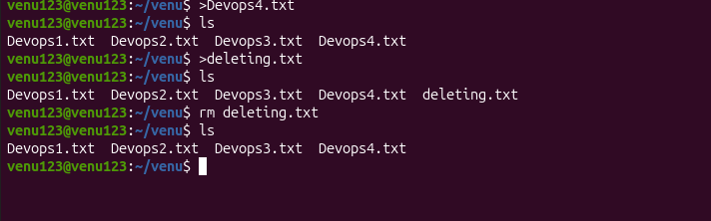

. Grant or revoke permissions on a file or directory.
To grant or revoke permissions on a file or directory in Linux use the chmod (change mode) command. You can modify permissions using symbolic mode (letters like u g o and + -) or absolute mode (three-digit octal numbers like ).
. Understanding Linux Permission Structures
Every file and directory has three user categories:
- User (u): The owner of the file.
- Group (g): Members of the file's assigned group.
- Others (o): Any other user on the system.
There are three basic access types:
- Read (r): Read a file or list directory contents.
- Write (w): Modify a file or add/delete items in a directory.
- Execute (x): Run a script/executable or enter a directory.

. Method : Using Symbolic Mode (Letters)
This method uses mathematical operators to add or remove privileges without altering other existing settings.
- + Grants a permission.
- - Revokes a permission.
- = Explicitly sets a permission (overwrites existing).
Examples:
- Grant write access to the group:

chmod g+w filename

- Revoke read and write access from others:

chmod o-rw filename

- Grant execute access to everyone:

chmod a+x filename

(Note: a stands for all user categories).

. Method : Using Absolute Mode (Numeric Values)
According to documentation from platforms like Red Hat and tutorials on Pluralsight numeric permissions use a -digit system where each digit represents a total score for User Group and Others:
- = Read (r)
- = Write (w)
- = Execute (x)
- = No permission
You add these numbers together to form each digit. For instance Read + Write + Execute (++) equals .
Value | Permissions | Meaning
 | rwx | Read write and execute
 | rw- | Read and write
 | r-x | Read and execute
 | r-- | Read-only
Examples:
- Set standard web folder permissions (Owner full access others read/execute):

chmod foldername

- Set private file permissions (Only owner can read and write):

chmod filename

. Handling Directories and Advanced Scenarios
- Apply changes recursively (Folder and all its contents):
To change a folder along with all files and subfolders inside it add the uppercase -R flag. Experts on Stack Overflow recommend using this carefully to avoid over-granting permissions.

chmod -R /path/to/directory

- Permission Denied?
If you do not own the file or directory you must prepend sudo to run the command with administrative privileges:

sudo chmod filename

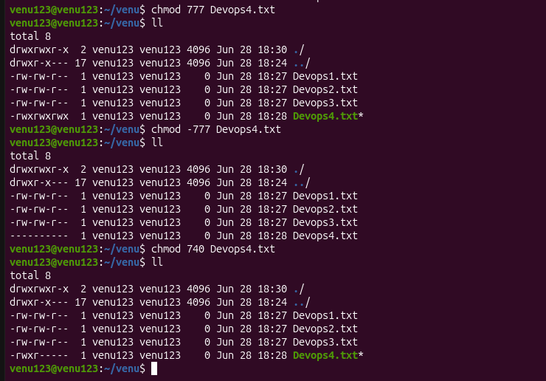

.View the current date and time.
To view the current date and time in Linux open your terminal and run the date command.
This basic utility outputs a detailed string containing the day of the week month day local time timezone and year.
Standard Commands
- Default View:

date

Output example: Mon Jun :: UTC
- Detailed System Clock & NTP Status:

timedatectl

This modern systemd command on nixCraft or Ask Ubuntu shows the local time universal time (UTC) RTC clock and whether network time synchronization is active.
Customized Format Examples
You can pass custom parameters with a + prefix to the date command to change how the text looks according to documentation on GeeksforGeeks:
- View Only Time (HH:MM:SS): date +"%T"
- View Only Date (MM/DD/YY): date +"%D"
- ISO Format (YYYY-MM-DD): date +"%F"
- Coordinated Universal Time: date -u
Bonus: Continuous Live Clock
If you want to view a real-time digital clock right inside your terminal combine date with the watch utility:

watch -n date

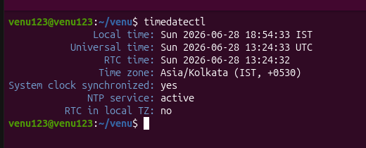

. Check the system uptime:
To check the system uptime in Linux the most direct method is to run the uptime command in your terminal. This returns a one-line summary displaying the current time how long the system has been running the number of logged-in users and the system load averages.
Below is a breakdown of the best commands to check system runtime and boot statistics.
. The Standard uptime Command
Running this command with different flags provides varying levels of detail:
- Standard output: Displays general stats including load averages.

uptime

Sample output: :: up days : users load average: . . .
- Human-readable format: Shows only the exact duration in plain text.

uptime -p

Sample output: up days hours minutes
- Last boot timestamp: Shows the exact date and time the system started up.

uptime -s

Sample output: -- ::
. Alternative Commands
If you need more than just the runtime summary several alternative tools print uptime information alongside other metrics:
- w command: Shows who is logged in and what they are doing with the system uptime featured right in the top header line.

w

- who -b command: Quickly pulls the specific date and time of the last system boot.

who -b

- top or htop monitors: Real-time process viewers that display the system uptime in the very first few lines of their interface.

top

. Reading Raw Kernel Data (For Scripting)
If you are writing a script and need the raw uptime in seconds without formatting parse the pseudo-filesystem directly using Linux /proc/uptime:

cat /proc/uptime

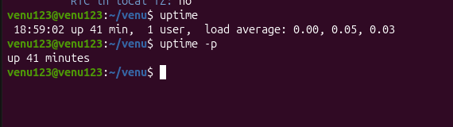

. View the running processes
To view running processes in Linux the most common and comprehensive command is ps aux or ps -ef for a static snapshot and top or htop for a real-time interactive view.
Here is a breakdown of the primary tools available to check active processes depending on your needs.
📋 Static Process Snapshots
These commands capture a snapshot of the processes running at the exact moment you press Enter.
- ps aux: Displays detailed information about every running process across all users on your system.
  - a: Shows processes for all users.
  - u: Adds detailed columns like CPU and memory usage.
  - x: Includes processes not attached to a terminal like background system services.
- ps -ef: An alternative standard format that prints all running processes with their Parent Process IDs (PPIDs) making it easier to see which process started what.
- ps -u username: Filters and displays processes belonging only to a specific user.
🔄 Real-Time Dynamic Monitoring
If you need to monitor resource spikes or watch active resource consumption live use interactive terminal tools.
- top: The standard pre-installed real-time monitor. It continuously refreshes every few seconds to show resource usage sorted by the heaviest CPU consumers. Press q to exit.
- htop: A modern colorful and user-friendly evolution of top. It features interactive mouse support and easy keyboard navigation to sort columns or kill processes. (Note: If not pre-installed you can usually add it via your package manager using sudo apt install htop or sudo dnf install htop.)
🔍 Finding Specific Processes
When your process list is massive and you want to look for one specific application utilize these filtering commands:
- ps aux | grep process_name: Standard approach to pipe the massive list into a keyword search tool.
- pgrep process_name: Directly searches the system and returns only the unique Process ID (PID) number for the matched program.
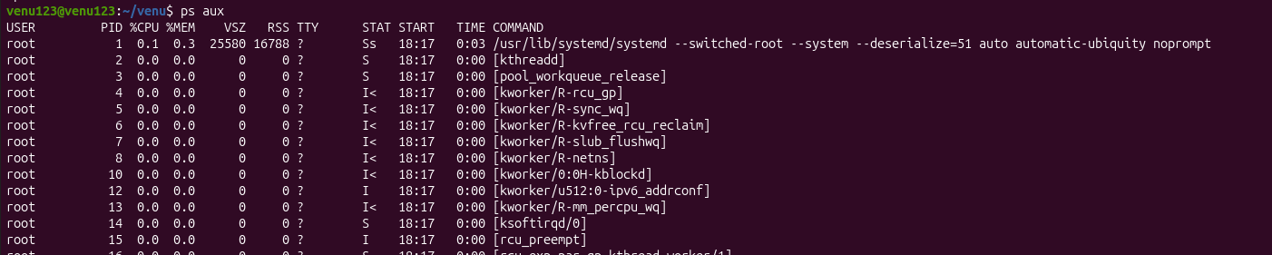
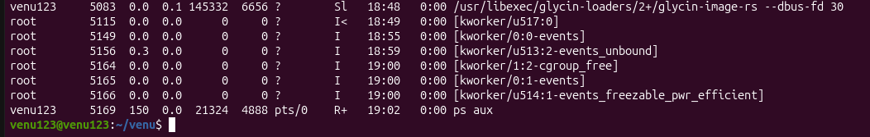

. Kill a running process
To kill a running process in Linux the standard way is to use the kill command followed by the process ID (PID) or the pkill command followed by the process name. Always try a graceful termination first and only force-kill the process if it becomes completely unresponsive.
. Find the Process ID (PID)
Before you can terminate a specific process you need to find its identifier:
- By Name: Run pgrep process_name or pidof process_name to get just the PID numbers.
- By Keyword Search: Run ps aux | grep process_name to see detailed information including the PID (located in the second column).
- Interactive Tool: Run top or htop to find resource-heavy programs and copy their PID.
. Terminate the Process
Once you have the PID or the exact name choose one of the following methods depending on the situation:
Method A: Graceful Kill (Recommended)
This sends a SIGTERM signal allowing the program to save its data and close file connections cleanly.
- By PID: kill <PID> (e.g. kill )
- By Name: pkill process_name (e.g. pkill firefox)
Method B: Force Kill (Stuck/Frozen Apps)
If the program refuses to close use the SIGKILL (-) signal. This immediately cuts the process from the CPU scheduler but may cause unsaved data loss.
- By PID: kill - <PID>
- By Name: pkill - process_name
Method C: Kill All Instances at Once
If you want to terminate every instance of a program (e.g. multiple open terminal or browser windows) use killall:
- Graceful: killall process_name
- Forceful: killall - process_name
Troubleshooting Permissions
If you see an "Operation not permitted" error message it means the process belongs to another user account or the operating system. Prefix your command with sudo to bypass this restriction:

sudo kill - <PID>
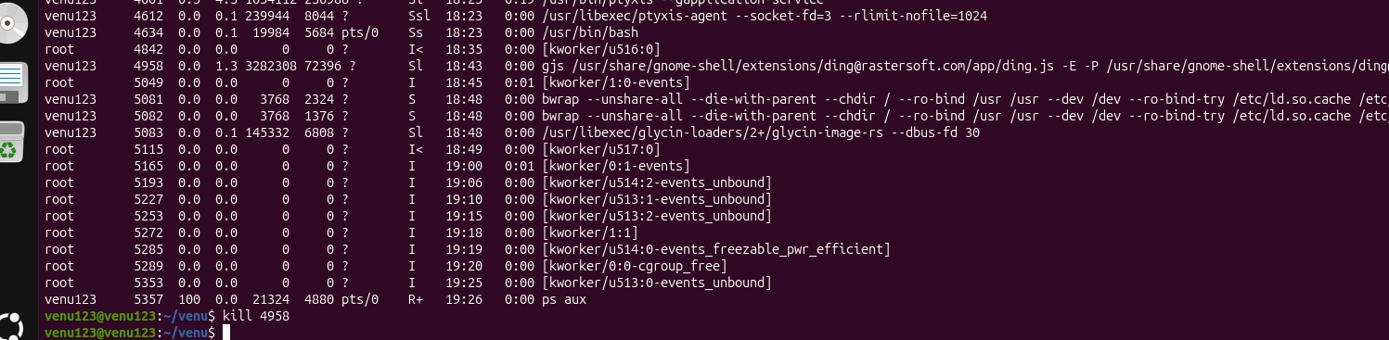
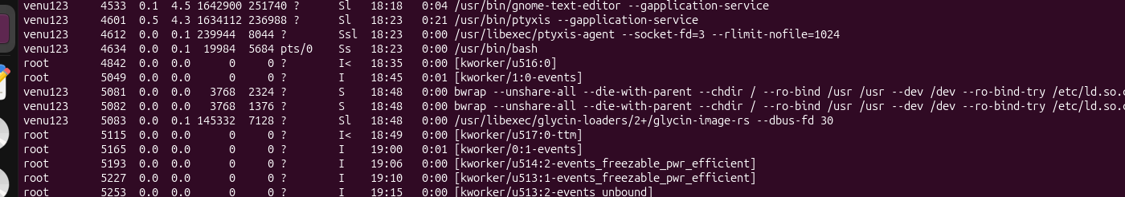
. Install a package using the package manager (e.g. apt or yum)
To install a package using a Linux package manager use sudo apt install <package_name> on Debian-based systems (like Ubuntu) or sudo yum install <package_name> on Red Hat-based systems (like RHEL or CentOS).
Quick Comparison Matrix
Distribution Family | Package Manager Tool | Primary Installation Command
Debian / Ubuntu | APT | sudo apt install <package_name>
RHEL / CentOS / Amazon Linux | YUM / DNF | sudo yum install <package_name>

Option : Debian-based Systems (Ubuntu Mint Debian)
The Advanced Package Tool (APT) manages applications on these platforms. You can learn more about its structure on DigitalOcean's Package Management Guide.
- Update package listings
Fetch the latest version data from your repositories:

sudo apt update

- Install your software
Replace curl with your preferred package name:

sudo apt install curl

- Verify the completion
Confirm that the package database reflects the change:

apt list --installed | grep curl

Option : Red Hat-based Systems (RHEL CentOS Fedora)
Yellowdog Updater Modified (YUM) and its modern successor DNF manage applications on these platforms. Review detailed operations via GeeksforGeeks' YUM Guide.
- Search for your software (Optional)
Verify that the package exists inside your enabled repositories:
Bash
yum search curl

- Install your software
Execute the installation command with administrative rights:

sudo yum install curl

(Note: On newer systems like RHEL + substitute yum with dnf for optimized performance.)
- Verify the completion
Confirm the application installed successfully:

yum list installed curl

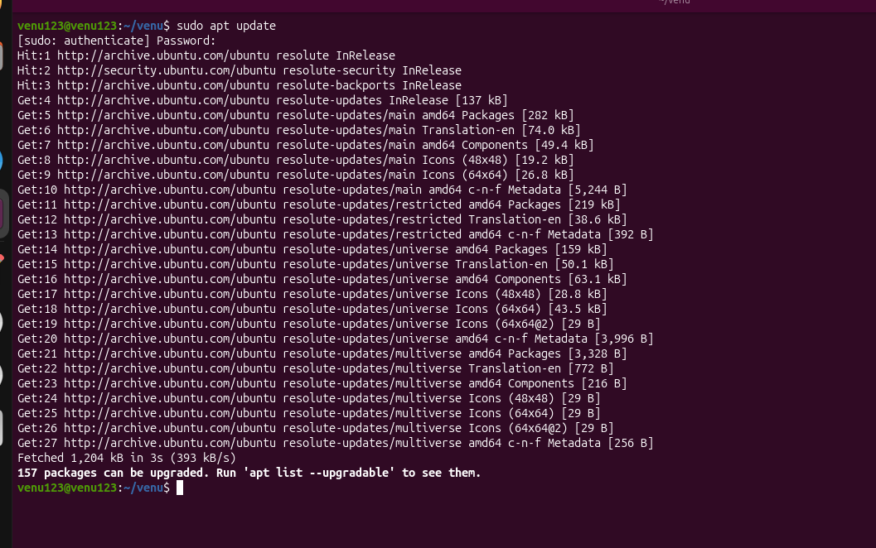

. Update the system packages
To update system packages in Linux you must use the specific package manager assigned to your distribution because Linux does not have a single universal update command. You will need to open your terminal and run the commands matching your operating system.
Ubuntu / Debian / Linux Mint / Kali Linux
These distributions rely on the APT package manager. Refreshing and applying updates requires a two-step process:
- Update package listings: Fetch the latest information on what needs updating.

sudo apt update

- Upgrade the actual packages: Download and install the pending software versions.

sudo apt upgrade -y

(Note: You can combine them into a single step using sudo apt update && sudo apt upgrade -y).
Fedora / Red Hat Enterprise Linux (RHEL +) / Rocky Linux
Modern Red Hat variants use the DNF package manager. Check out the guide on Medium or read the GeeksforGeeks Package Manager Introduction to learn more about how DNF automates system maintenance.
- Upgrade all packages: DNF syncs repositories and installs updates automatically in one command.

sudo dnf upgrade -y

CentOS / Older RHEL ( and below)
Older enterprise distributions use the legacy YUM package manager. If you manage an enterprise server environment you can reference the Red Hat Customer Portal for detailed safety protocols before applying upgrades.
- Update all packages:

sudo yum update -y

Arch Linux / Manjaro
Arch-based distributions use a rolling release system managed by Pacman.
- Synchronize and update everything:

sudo pacman -Syu

OpenSUSE / SUSE Linux Enterprise
SUSE systems use the Zypper command line utility.
- Apply all distribution updates:

sudo zypper dup

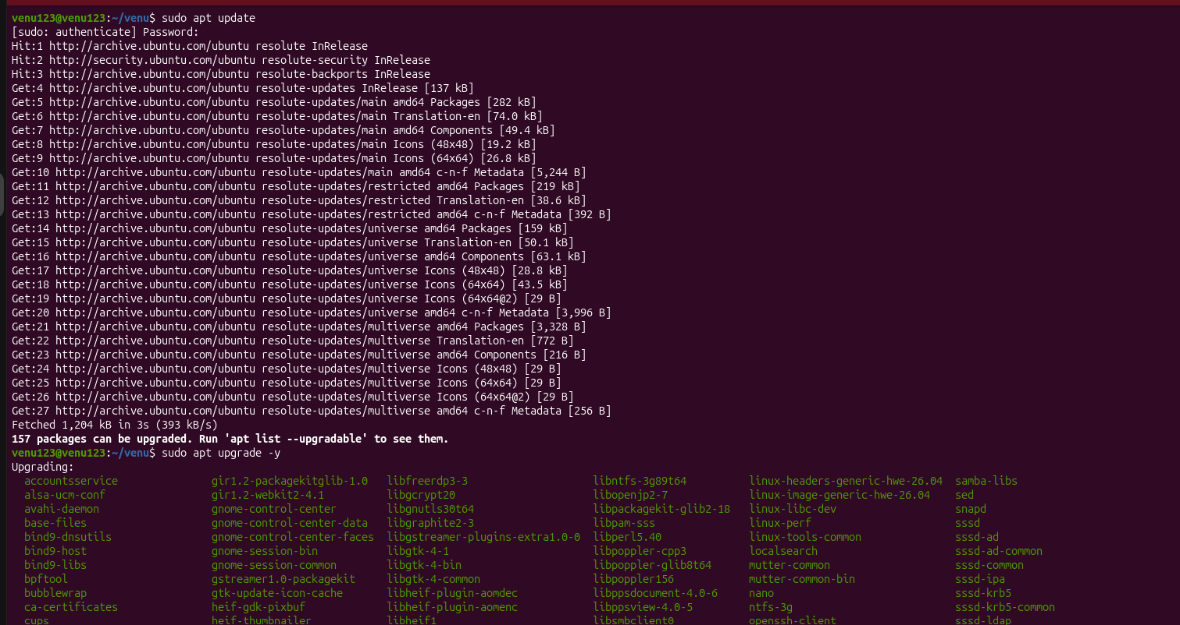
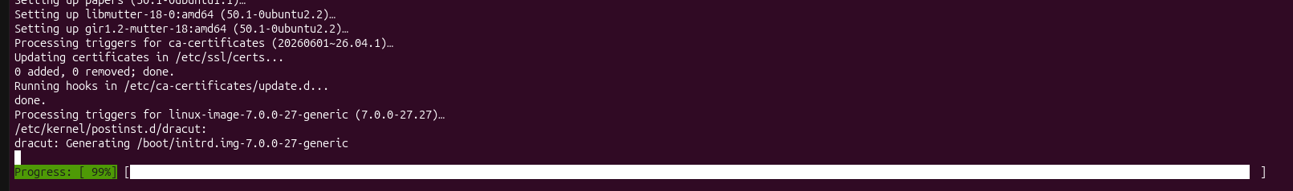
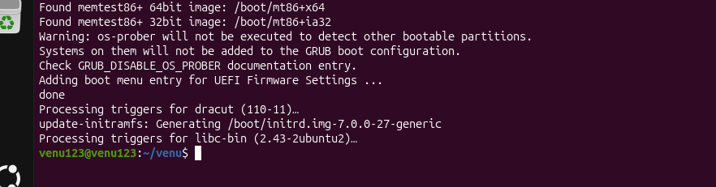

. Create a symbolic link.
To create a symbolic link (symlink) in Ubuntu Linux use the ln -s command in your terminal.
Basic Command Syntax

ln -s /path/to/original_target /path/to/symlink_name

- /path/to/original_target: The existing file or directory you want to point to.
- /path/to/symlink_name: The path and name of the shortcut you are creating.

Common Examples
- Link a File
Create a shortcut named shortcut.txt in your current folder that points to a document in your Documents folder:

ln -s /home/user/Documents/report.txt shortcut.txt

- Link a Directory (Folder)
Create a shortcut named my_movies that links directly to a folder on a secondary drive:

ln -s /media/drive/Movies /home/user/my_movies

- Force Overwrite an Existing Link
If a file or link already exists at the destination the command will fail. Use the -f flag to overwrite it:

ln -sf /path/to/original_target /path/to/symlink_name

- Create System-Wide Links (Using sudo)
If you are creating a link inside system folders (like /usr/bin) you must precede the command with sudo:

sudo ln -s /opt/my_app/bin/launch /usr/bin/launch

Managing Symlinks
- Verify the Link
Check if your link was created successfully by running ls -l:

ls -l /path/to/symlink_name

An arrow (->) will display explicitly showing you where the link points.
- Delete a Symlink
You can safely delete a symbolic link using rm or unlink without affecting the original file:

rm /path/to/symlink_name
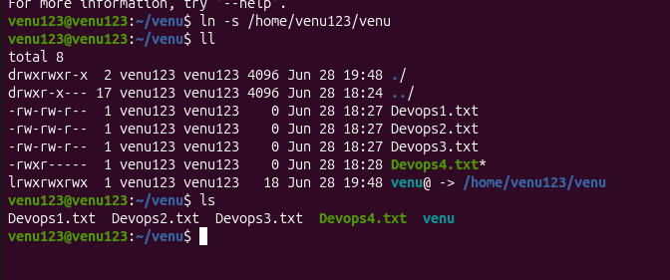

. Search for files using the find command
To search for files using the find command in Linux Ubuntu use the basic syntax find [path] [options] [expression]. If you omit the path the system defaults to searching your current working directory.
Here is a quick-start guide to the most common search patterns using the Linux find tool.
🔍 Search by Name or Extension
- Exact match (Case-Sensitive): Search for a specific file name in the current directory.

find . -name "document.txt"

- Case-Insensitive match: Use -iname to find a file regardless of uppercase or lowercase letters.

find /home -iname "document.txt"

- By Extension: Find all files ending with a specific extension (e.g. .log) across the entire system.

sudo find / -name "*.log"

📂 Search by File Type
- Files only: Use -type f to restrict your search strictly to regular files ignoring folders.

find . -type f -name "backup*"

- Directories only: Use -type d to look exclusively for folders.

find /var -type d -name "nginx"

⚖️ Search by Size
- Larger than a threshold: Find files larger than Megabytes.

find . -type f -size +M

- Smaller than a threshold: Find files smaller than Kilobytes.

find . -type f -size -k

- Empty files: Quickly track down empty items using the -empty flag.

find /tmp -type f -empty

⏱️ Search by Modification Time
- Last hours: Find files modified within the last single day.

find ~ -type f -mtime -

- Last X minutes: Find files modified within the last minutes.

find /var/log -type f -mmin -

⚙️ Combine & Execute Actions
- Search inside file contents: Chain find with grep to look for specific text strings inside your files.

find . -type f -name "*.txt" -exec grep "Error" {} \;

- Find and delete: Locate temporary files and delete them instantly (use caution).

find . -name "*.tmp" -delete

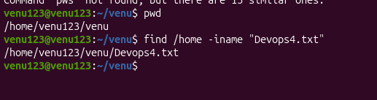

. Compress and decompress files using tar
To compress files using the tar command in Ubuntu Linux run tar -czvf archive_name.tar.gz /path/to/directory_or_file; to decompress it run tar -xzvf archive_name.tar.gz.
The tar utility bundles multiple files into a single package while flags like -z compress the package using the gzip algorithm to save disk space.
Flag Breakdown
- -c: Create a new archive file.
- -x: Extract files from an existing archive.
- -z: Compress or decompress using the gzip utility.
- -v: Verbose mode to display progress in the terminal.
- -f: Specifies the filename of the archive.

. Compressing Files and Directories
You can build compressed archives using various formats depending on your needs. For standard guides on this process you can reference documentation on How-To Geek or freeCodeCamp.
Gzip Format (Most Common: .tar.gz)
Balances speed and file size reduction efficiently.

tar -czvf my_archive.tar.gz /path/to/folder

Bzip Format (.tar.bz)
Slower than Gzip but achieves a higher compression ratio for smaller file sizes.

tar -cjvf my_archive.tar.bz /path/to/folder

XZ Format (.tar.xz)
Takes the longest time to compress but provides the highest compression ratio.

tar -cJvf my_archive.tar.xz /path/to/folder

. Decompressing Archives
When extracting packages modern GNU tar on Ubuntu can automatically identify the compression style. Detailed extraction configurations are available via GeeksforGeeks.
Decompress to Current Directory
Run the extraction flag on your archive. It safely targets .tar.gz .tar.bz or .tar.xz formats seamlessly.

tar -xzvf my_archive.tar.gz

(Note: You can omit the z flag and run tar -xf my_archive.tar.gz because tar will auto-detect the layout.)
Decompress to a Specific Directory
Add the -C flag followed by your desired destination folder path.

tar -xzvf my_archive.tar.gz -C /path/to/destination_folder

. Quick Operations
View Archive Contents Without Extracting
Preview what is inside the file before unpacking it to prevent cluttering your folders.

tar -tzvf my_archive.tar.gz

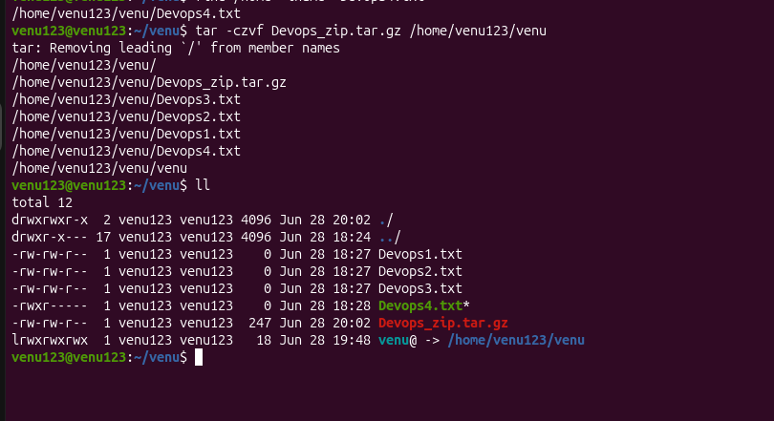

.Monitor system resources with top or htop
To monitor system resources in Linux Ubuntu you can use the built-in top command or the more modern interactive htop utility. While top comes pre-installed on almost all Ubuntu installations htop offers a much cleaner color-coded interface that supports scrolling and mouse clicks.
Here is how to install launch and use both tools to manage your system resource usage.
📊 Monitoring with htop (Recommended)
htop is generally preferred for day-to-day interactive troubleshooting. It displays separate usage bars for each CPU core and provides easy-to-remember function key menus.
. Install htop
htop is usually not included by default on standard Ubuntu server minimal images. Install it using the apt package manager:

sudo apt update && sudo apt install htop -y

. Launch htop
Simply type the command into your terminal:

htop

. Essential htop Keyboard Shortcuts
- F: Search for a specific process by name.
- F: Filter the process list to show only matching text.
- F: Toggle Tree View to trace parent-child process relationships.
- F: Change the sorting column (e.g. sort by %MEM or %CPU).
- F: Kill/terminate the currently selected process safely.
- Shift + H: Hide or show individual process threads to clear up the view.
- q or F: Exit the utility.

📉 Monitoring with top (Universal)
The traditional top tool is invaluable because it is guaranteed to be available on any Linux machine you log into.
. Launch top
Open your terminal and run:

top

. Essential top Keyboard Shortcuts
- : Toggle between an aggregated CPU view and individual CPU core breakdowns.
- z: Toggle color highlights on or off to make data scanning easier.
- M (Shift + M): Sort all running processes by Memory usage.
- P (Shift + P): Sort all running processes by CPU usage.
- d: Change the refresh rate interval (the default is seconds).
- k: Kill a process (it will prompt you for the specific Process ID or PID).
- q: Exit the utility.

🔍 Quick Comparison
Feature | top Command | htop Command
Availability | Pre-installed everywhere | Requires quick installation
Interface | Plain text monochrome by default | Color-coded with resource bar graphs
Navigation | Keyboard shortcuts only | Supports arrow keys & mouse clicks
Process Management | Manual PID entry required to kill | Scroll and kill with function keys
TOP:
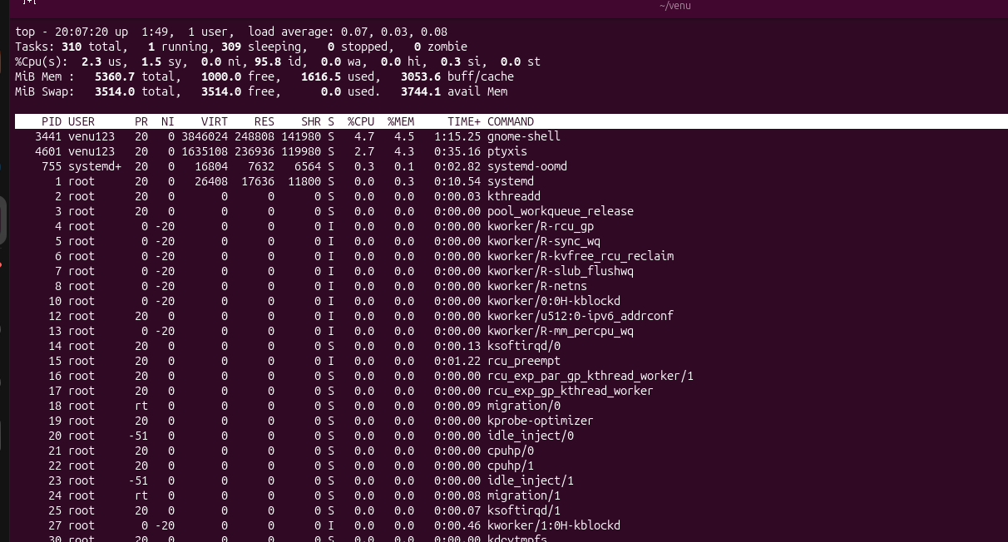

HTOP:
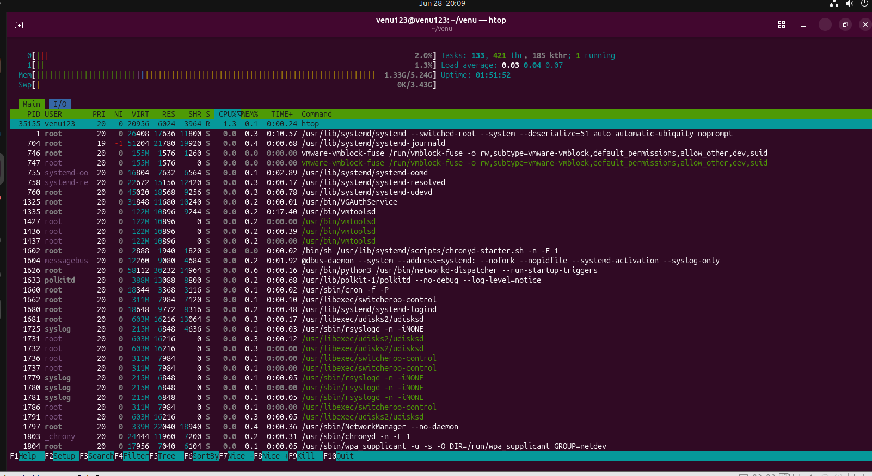

. Create and manage user groups
To manage user groups in Ubuntu Linux you primary utilize terminal commands like groupadd usermod and groupdel to efficiently handle permissions. Group management in Ubuntu allows you to grant multiple users identical read write or administrative access simultaneously.
. Creating Groups
You can add a new group to the system using the groupadd utility.
- Standard Group: Create a basic group.

sudo groupadd developers

- Specific GID: Force a custom Group ID number.

sudo groupadd -g dbadmins

. Managing Group Members
Adding or removing members modifies the user parameters rather than the group itself. []
- Add Existing User: Append a user to a secondary group. Always use -a (append) with -G so you do not accidentally remove them from other groups.

sudo usermod -aG developers john

- Alternative Add Command: Use gpasswd to add a user.

sudo gpasswd -a john developers

- Remove User from Group: Explicitly remove a user's access from a group.

sudo gpasswd -d john developers

- Session Refresh: Note that users must log out and log back in for new group assignments to activate.
. Modifying and Deleting Groups
These commands let you alter properties or permanently remove existing groups from /etc/group.
- Rename Group: Change the label of an existing group.

sudo groupmod -n new_name old_name

- Change Group ID: Alter the assigned GID.

sudo groupmod -g groupname

- Delete Group: Wipe a group entirely. (This will not delete the users inside it but they will lose associated permissions).

sudo groupdel developers

. Viewing and Verifying Groups
Check your adjustments using inspection commands to read system identity configurations.
- List All Groups: View every group configured on the system.

cat /etc/group

- List User's Groups: Display all groups a specific user belongs to.

groups john

- List Group Members: Identify all users linked inside a target group.

getent group developers
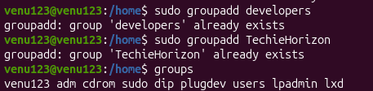

. Set up SSH password less authentication
To set up passwordless SSH authentication on Ubuntu you must generate an SSH key pair on your local computer and transfer the public key to your remote Ubuntu server. [ ]
Follow this three-step guide to get it configured instantly.
Step : Generate an SSH Key Pair
Run this command on your local machine (your laptop or desktop) to generate a secure ED cryptographic key pair: [ ]

ssh-keygen -t ed

- Press Enter to accept the default file save path (~/.ssh/id_ed).
- Press Enter twice when prompted for a passphrase to leave it completely blank for fully automated passwordless access. [ ]
Step : Copy the Public Key to your Ubuntu Server
Use the built-in utility to automatically copy your new public key over to the remote Ubuntu server. Replace username and remote_ip with your actual remote server details: [ ]

ssh-copy-id username@remote_ip

- Enter your remote server's account password one last time when prompted.
- The script will automatically create the ~/.ssh directory on the server and append your key to the authorized_keys file with the correct security permissions. [ ]
Step : Verify the Connection
Test that you can now log in securely without typing a password: [ ]

ssh username@remote_ip

You should instantly gain access to the remote Ubuntu command line terminal without any password prompt. []

Optional: Disable Password Authentication Completely
Once you confirm that key-based login works you should disable standard password entry to shield your server from internet brute-force attacks. [ ]
- On the remote server open the main configuration file:

sudo nano /etc/ssh/sshd_config

- Find the following lines and change their values to no:
text
PasswordAuthentication no
ChallengeResponseAuthentication no
KbdInteractiveAuthentication no

- Save the file (Ctrl + O then Enter) and exit (Ctrl + X).
- Apply the security changes by restarting the OpenSSH server daemon:

sudo systemctl restart ssh
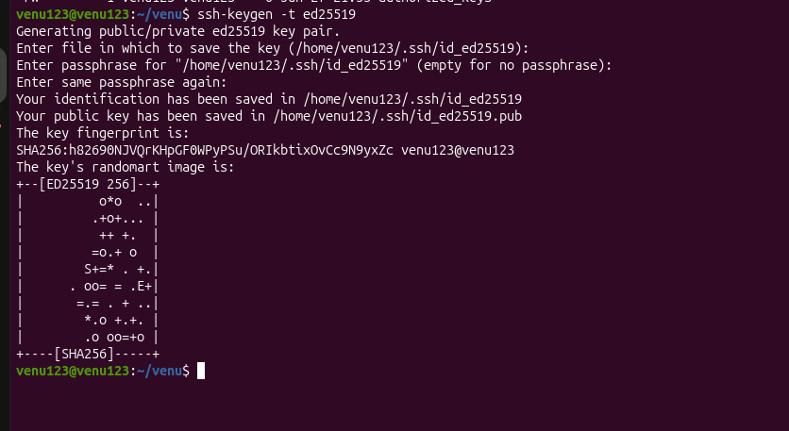

. Monitor log files using tail or grep
To monitor log files in Linux Ubuntu use the tail -f command to stream logs in real time or pipe the stream into grep to filter out specific keywords like errors.
Real-Time Monitoring with tail
The tail utility defaults to printing the final lines of a document.
- Follow live updates: The -f switch locks onto the active file descriptor and appends incoming system events to your terminal.

sudo tail -f /var/log/syslog

- Handle log rotations: Use the uppercase -F parameter if an active background program rotates or recreates its text targets dynamically.

sudo tail -F /var/log/nginx/access.log

- Adjust initial output: Track specific line batches by passing numerical parameters alongside the primary flag.

sudo tail -n -f /var/log/auth.log

(Note: Exit active streaming streams at any time using the Ctrl + C shortcut).
Filtering Live Entries with grep
Combine both command structures to filter out unstructured noise and highlight specific operations. You can reference detailed filter patterns on tutorials listed via Ubuntu Docs or GeeksforGeeks.
- Isolate clear match targets: Stream entries matching specific terms or application processes.

sudo tail -f /var/log/syslog | grep "CRON"

- Ignore letter casing: Insert the -i parameter to target broad keyword definitions like variations of "error".

sudo tail -f /var/log/nginx/error.log | grep -i "denied"

- Enforce regular expressions: Use the -E flag to monitor multiple severe categories simultaneously.

sudo tail -f /var/log/syslog | grep -E "error|critical|fatal"

Static Diagnostic Audits with grep
If you need to analyze historical failures rather than watching live activities execute standalone search queries directly across local system log paths.
- Isolate explicit historical patterns: Scan complete uncompressed logs for specific errors.

sudo grep "failed" /var/log/auth.log

- Inspect compressed log backups: Ubuntu frequently packages older historical logs into .gz formats via logrotate. Review these archives using zgrep without manually extracting them.

sudo zgrep "kernel panic" /var/log/syslog..gz

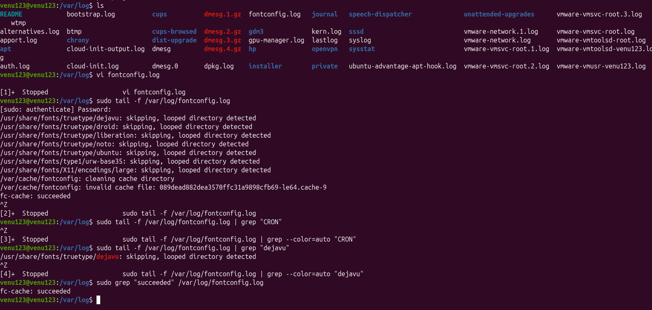

. Set up a web server (e.g. Apache or Nginx)
To set up a web server on Ubuntu Linux you can choose between Nginx (highly optimized for static files and reverse proxying) or Apache (famous for its robustness modules and .htaccess flexibility). [ ]
Below are the direct step-by-step instructions for installing and configuring either server option. Choose only one option as they both listen on port by default. [ ]

Option : Setting up Nginx
. Install Nginx []
Update your package index and install the software: [ ]

sudo apt update
sudo apt install nginx -y

. Configure Firewall
Allow HTTP traffic through the Uncomplicated Firewall (UFW): [ ]

sudo ufw allow 'Nginx HTTP'

. Verify Server Status []
Check that the service is active and running: [ ]

sudo systemctl status nginx

Open a browser and navigate to your server's IP address (or http://localhost). You will see the default Nginx Welcome Page. [ ]
. Host a Custom Website (Optional) []
The default web root is /var/www/html. To host your own website replace the contents of this folder or follow the DigitalOcean Nginx Server Block Guide to set up multiple virtual hosts.

Option : Setting up Apache
. Install Apache
Update your package repository list and install the Apache package: []

sudo apt update
sudo apt install apache -y

. Configure Firewall
Allow standard web traffic through UFW: [ ]

sudo ufw allow 'Apache'

. Verify Server Status []
Verify that Apache is running without errors: [ ]

sudo systemctl status apache

Type your server's IP address or http://localhost into a web browser. The Apache Ubuntu Default Page will appear. [ ]
. Manage Your Site files
- Default Directory: Add your HTML files directly to /var/www/html to change the landing page.
- Multiple Sites: To host multiple separate domains on the same server read the Ubuntu Apache Documentation to learn how to create distinct Virtual Host files.

Essential Service Management Commands
No matter which server you choose use these system commands to manage your service (replace nginx with apache if using Apache): [ ]
- Stop server: sudo systemctl stop nginx
- Start server: sudo systemctl start nginx
- Restart server: sudo systemctl restart nginx
- Reload configuration (Apply changes without stopping existing connections): sudo systemctl reload nginx
- Enable boot launch: sudo systemctl enable nginx

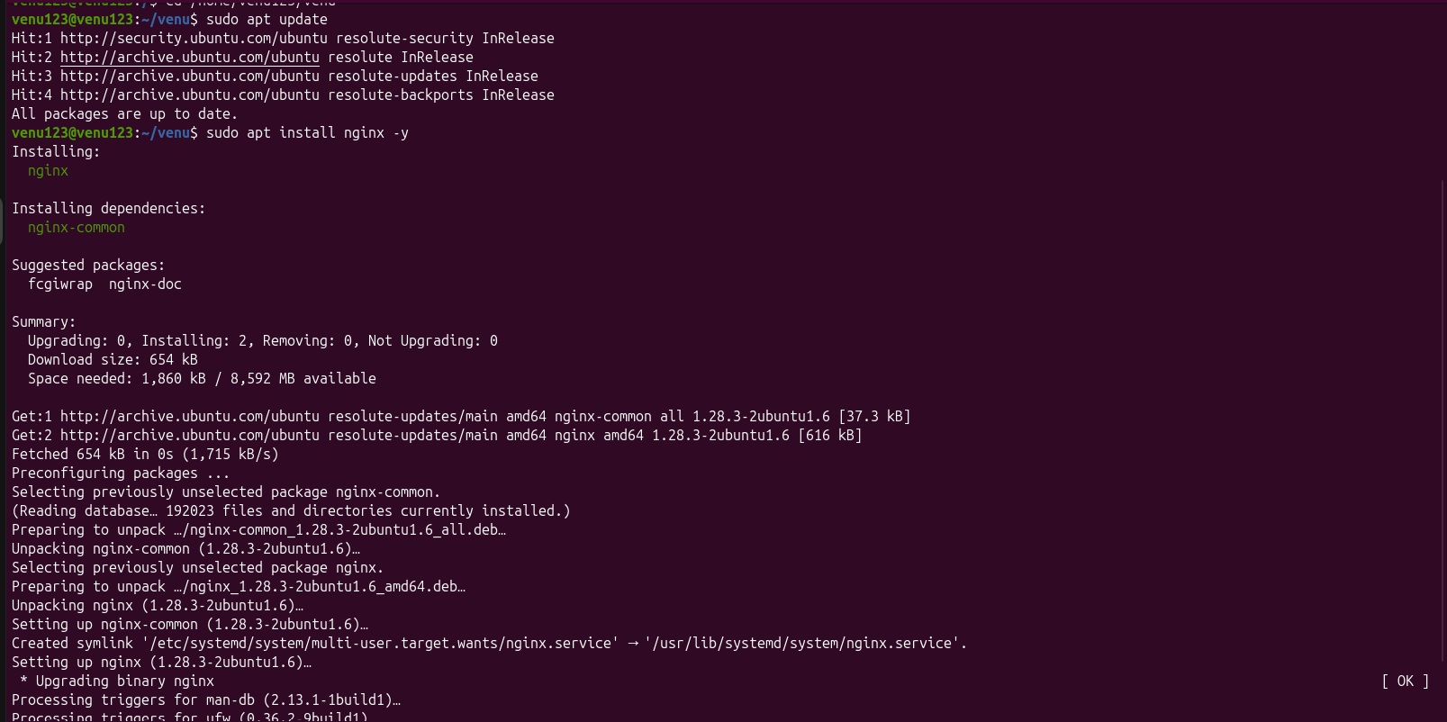
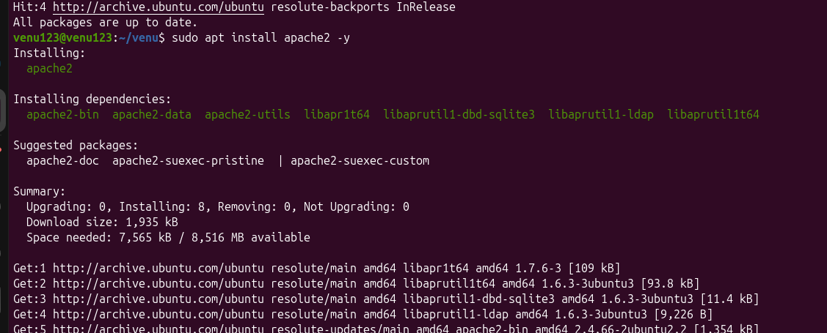

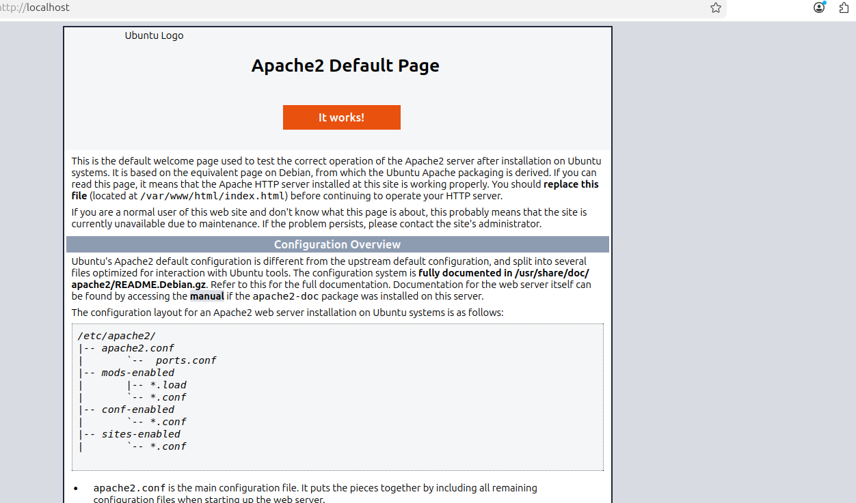
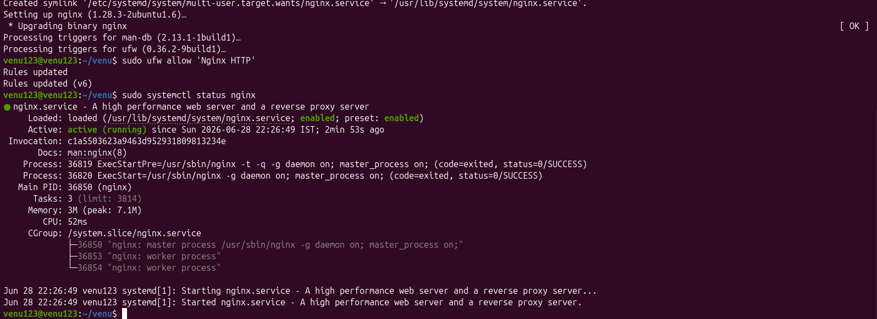
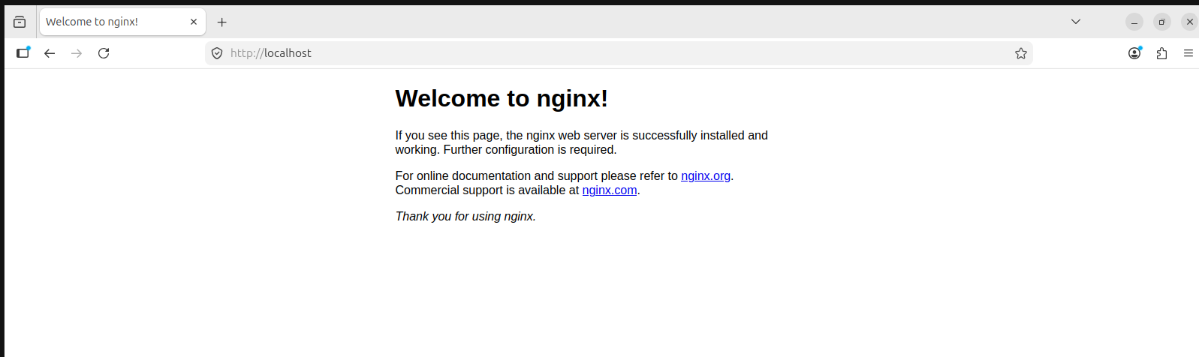

. Configure and secure a MySQL Database
To configure and secure a MySQL Database on Ubuntu Linux you must install the mysql-server package run the automated security script and configure proper network and user privileges. []
Here is the complete step-by-step guide to installing configuring and hardening your MySQL deployment.
. Install MySQL Server
Update your system's package index and install the official MySQL server package. [ ]

sudo apt update
sudo apt install mysql-server -y

Verify that the daemon is running using systemctl: [ ]

sudo systemctl status mysql

. Configure the Root Authentication
On modern Ubuntu releases the MySQL root user authenticates via the auth_socket plugin by default instead of a password. To configure standard password security manually change the authentication method inside the MySQL prompt: [ ]

sudo mysql

Inside the MySQL shell run the following command (replace YourStrongPassword with a unique robust password): [ ]
sql
ALTER USER 'root'@'localhost' IDENTIFIED WITH caching_sha_password BY 'YourStrongPassword';
FLUSH PRIVILEGES;
EXIT;

. Run the Security Hardening Script
MySQL includes an interactive tool called mysql_secure_installation to systematically lock down default server vulnerabilities. Start the script by running: [ ]

sudo mysql_secure_installation

When prompted by the script input the following security choices: [ ]
- Validate Password Component: Enter Y to enforce password complexity rules. Select a policy level (e.g. for Strong).
- Change Root Password: Skip this if you already configured a strong one in Step .
- Remove Anonymous Users: Enter Y to ensure only explicit user accounts can log in.
- Disallow Root Login Remotely: Enter Y to block hackers from attempting to brute-force the root user across the internet.
- Remove Test Database: Enter Y to delete default databases accessible to anyone.
- Reload Privilege Tables: Enter Y to immediately apply all security changes. [ ]
. Create a Dedicated Application User
Never connect your applications directly to the root account. Create a standard unprivileged user bound to localhost to perform regular database tasks: [ ]

mysql -u root -p

Run the following SQL block to initialize a fresh database and assign an application user to it: []
sql
CREATE DATABASE app_db;
CREATE USER 'app_user'@'localhost' IDENTIFIED WITH caching_sha_password BY 'AppSecurePassword';
GRANT ALL PRIVILEGES ON app_db.* TO 'app_user'@'localhost';
FLUSH PRIVILEGES;
EXIT;

. Secure Network Access and Enable Firewall
By default MySQL binds to ... (localhost) ensuring outside traffic cannot reach it. You can confirm this configuration inside the MySQL configuration file: [ ]

sudo nano /etc/mysql/mysql.conf.d/mysqld.cnf

Look for the bind-address directive and ensure it points locally: [ ]
text
bind-address = ...

For deep infrastructure security enable the Uncomplicated Firewall (UFW) on Ubuntu. If you require remote database administration never expose port publicly. Instead explicitly restrict port access to a specific trusted remote IP address: [ ]

sudo ufw enable
sudo ufw allow from TRUSTED_REMOTE_IP to any port proto tcp

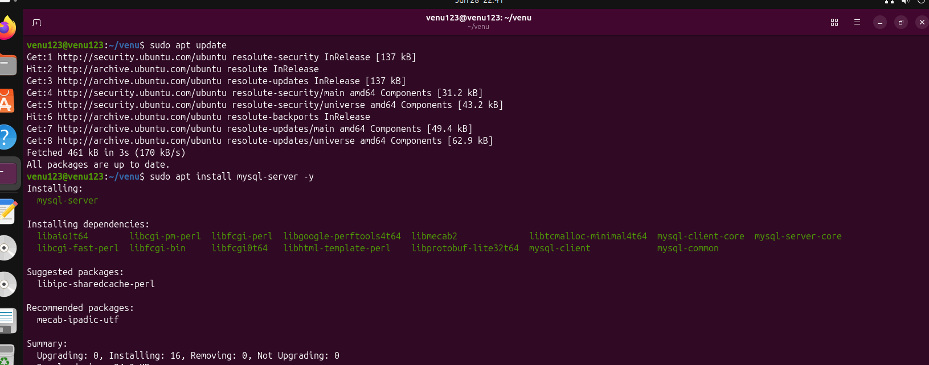
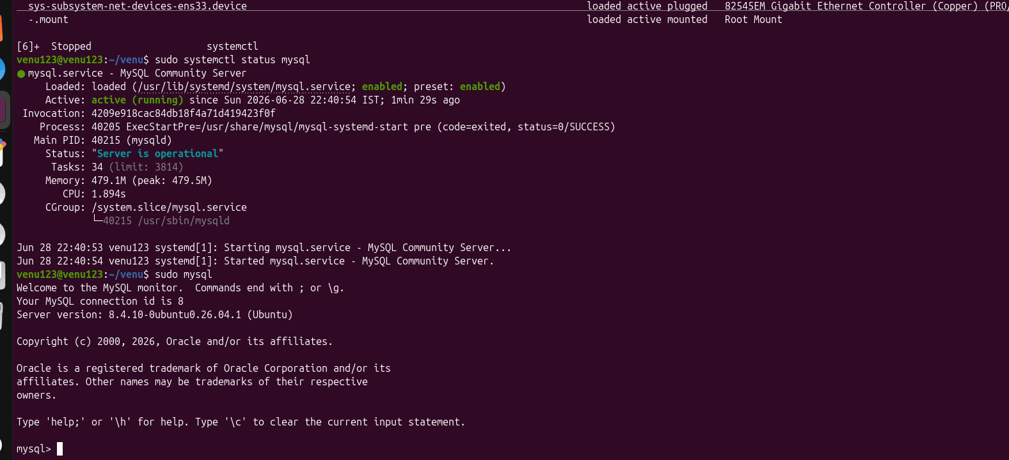

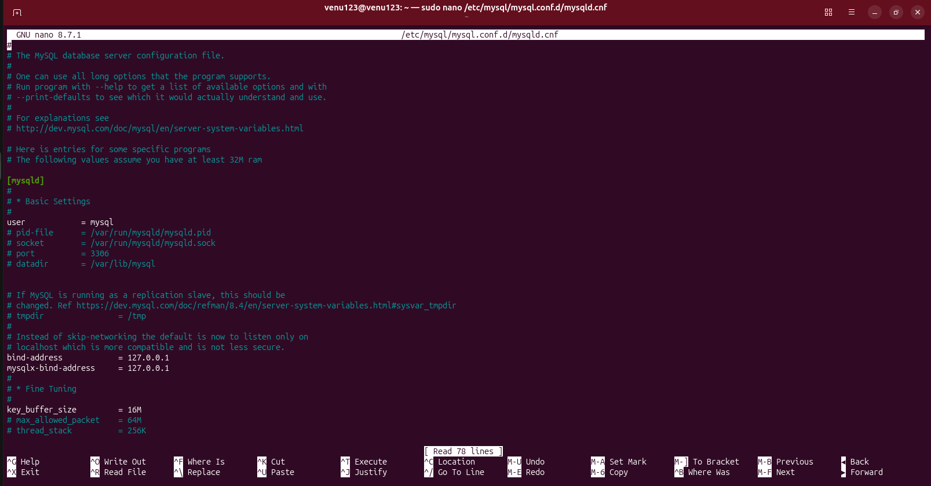

. create a service file for Apache Tomcat.(Should execute by using systemtctl command)
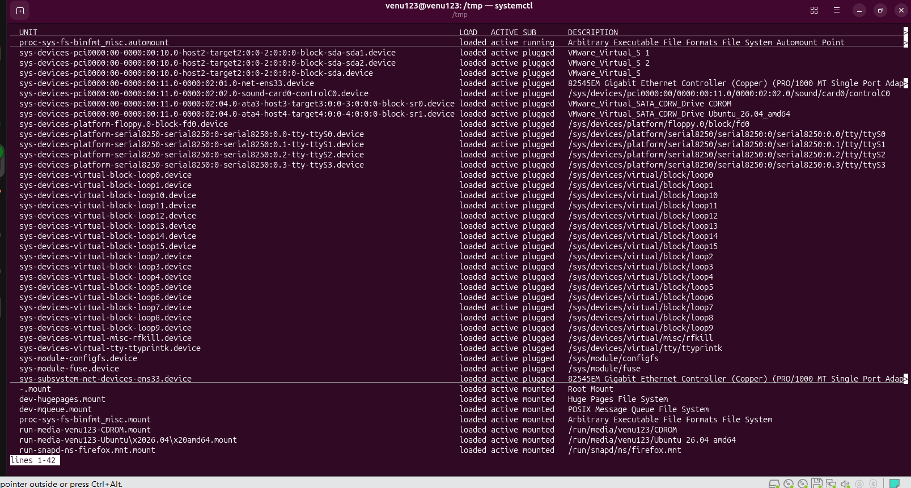

. Print specific columns from a delimited file.
To print specific columns from a delimited file in Linux Ubuntu use the cut command or the awk command. [ ]
Option : Using the cut Command
The GeeksforGeeks Linux cut Guide shows that cut is the simplest tool for basic file parsing. Use -d to state the delimiter and -f to pick columns.
- Comma-delimited (CSV): Print columns and .

cut -d '' -f filename.txt

- Tab-delimited: Print columns through .

cut -d $'\t' -f - filename.txt

- Space-delimited: Print the st column.

cut -d ' ' -f filename.txt

[ ]
Option : Using the awk Command
According to Stack Overflow awk examples awk handles messy whitespace much better than cut. Use -F to set the input delimiter.
- Comma-delimited (CSV): Print columns and with space separation.

awk -F '' '{print $ $}' filename.txt

- Comma-delimited (Output as CSV): Use OFS to keep a comma in the output.

awk -F '' 'BEGIN {OFS=""} {print $ $}' filename.txt

- Tab-delimited: Print columns and .

awk -F '\t' '{print $ $}' filename.txt

- Space-delimited (Multiple Spaces): Extracts the nd column natively.

awk '{print $}' filename.txt

[ ]
Summary Comparison
Feature [ ] | cut command | awk command
Best For | Simple files | Advanced text processing
Consecutive Delimiters | Treats each space as a separate column | Groups multiple spaces automatically
Speed | Extremely fast | Fast

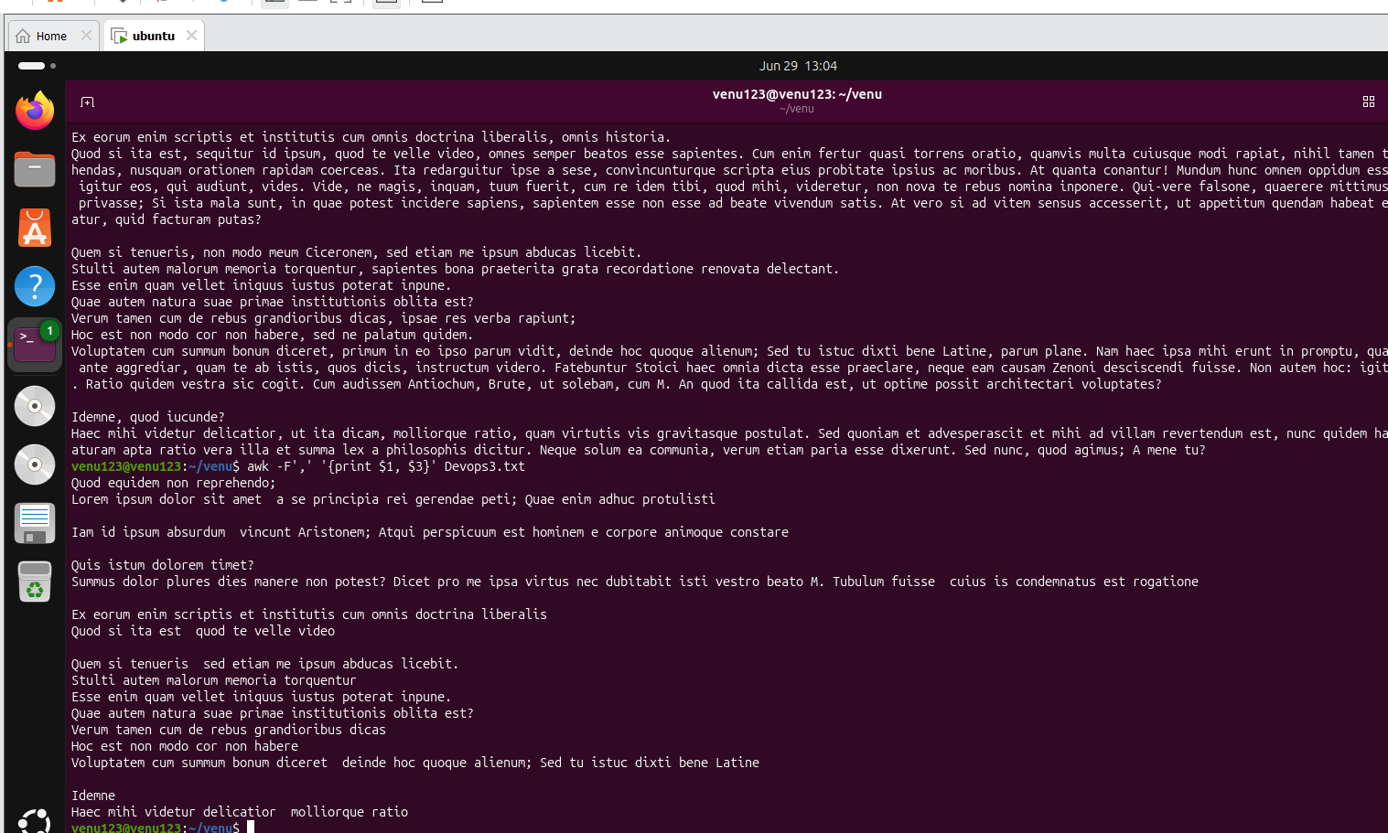

. Filter and print lines based on a specific pattern or condition
The primary tool for filtering and printing lines based on patterns in Linux Ubuntu is grep while awk and sed are used for more complex conditions. [ ]
Filter by Text Pattern (grep)
- Match a simple string:
grep "pattern" filename.txt
- Match case-insensitively:
grep -i "pattern" filename.txt
- Invert match (print lines NOT matching):
grep -v "pattern" filename.txt
- Match using Regular Expressions (Regex):
grep -E "^start.*end$" filename.txt [ ]
Filter by Column Conditions (awk)
- Print line if the rd column equals a value:
awk '$ == "value" {print}' filename.txt
- Print line if the nd column is greater than :
awk '$ > ' filename.txt
- Match a pattern in a specific column:
awk '$ ~ /pattern/' filename.txt [ ]
Filter by Line Numbers (sed)
- Print a specific line (e.g. line ):
sed -n 'p' filename.txt
- Print a range of lines (e.g. lines to ):
sed -n 'p' filename.txt
Filter Live Command Output
You can pipe | any command output into these filters:
cat logfile.log | grep "ERROR"
df -h | awk '$ > '

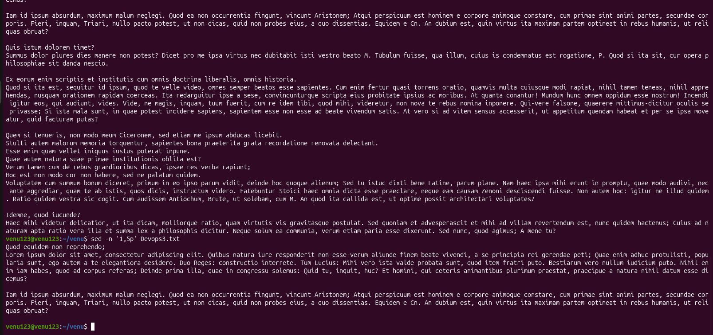

. Calculate and print the average sum or other statistics of a column
The most efficient way to calculate and print column statistics on Linux Ubuntu is by using either the awk command (pre-installed) or the datamash utility (for advanced metrics). [ ]

Method : Using awk (Built-in & Fast)
awk processes text file rows sequentially automatically splitting columns by any whitespace. Use $ to target the second column or change it to your target column number. [ ]
- Sum:

awk '{sum+=$} END {print sum}' filename.txt

[]
%%MAGIT_PARSER_PROTECT%% ``` []
- Average (Mean):
%%MAGIT_PARSER_PROTECT%% awk '{sum+=$} END {print sum/NR}' filename.txt %%MAGIT_PARSER_PROTECT%%
- Min Max and Average combined:
%%MAGIT_PARSER_PROTECT%% awk 'NR== {min=max=$} {sum+=$; if($>max) max=$; if($<min) min=$} END {print "Sum: "sum "Avg: "sum/NR "Min: "min "Max: "max}' filename.txt %%MAGIT_PARSER_PROTECT%% [ ]
(Note: NR is a built-in awk variable tracking the total number of records/rows). [ ]

Method : Using GNU datamash (Best for Detailed Statistics)
If you need complex summary statistics like median or standard deviation install datamash via your Ubuntu terminal:
%%MAGIT_PARSER_PROTECT%% sudo apt update && sudo apt install datamash -y %%MAGIT_PARSER_PROTECT%% []
Once installed use the following commands (assuming your column fields are separated by whitespace or tabs): [ ]
- Calculate basic statistics for Column :
%%MAGIT_PARSER_PROTECT%% datamash sum mean min max < filename.txt %%MAGIT_PARSER_PROTECT%%
- Calculate advanced statistics (Median & Std Dev):
%%MAGIT_PARSER_PROTECT%% datamash median sstdev < filename.txt %%MAGIT_PARSER_PROTECT%%
- Format output neatly into a table:
%%MAGIT_PARSER_PROTECT%% datamash --header-out sum mean min max < filename.txt | column -t %%MAGIT_PARSER_PROTECT%% []

Method : Using jq (For JSON Data Structures)
If your input file is a raw list of numbers or a JSON array you can pipe it directly into the jq utility: []
- Get all statistics at once:
%%MAGIT_PARSER_PROTECT%% seq | jq -s '{min: min max: max avg: (add/length)}' %%MAGIT_PARSER_PROTECT%%

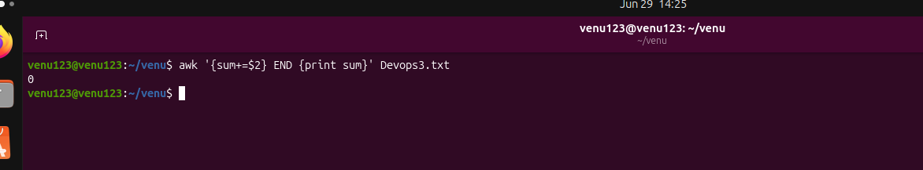

. Perform string manipulation such as extracting substrings or changing case
In Linux Ubuntu the fastest and most efficient way to perform string manipulation is by using native Bash Parameter Expansion. This method executes entirely inside the shell without needing to call external utilities like sed awk or cut. [ ]
Below is a scannable guide detailing how to extract substrings and change text casing directly in your Ubuntu terminal.

. Extracting Substrings
Native substring extraction uses -based indexing with the syntax ${variable:position:length}. [ ]

text="UbuntuLinux"

# Extract characters starting from index
echo ${text::} # Output: Ubunt

# Extract characters starting from index
echo ${text::} # Output: Linux

# Extract from index to the end of the string
echo ${text:} # Output: Linux

For comprehensive extraction methods you can reference The Linux Documentation Project or KodeKloud's Bash Substring Guide.

. Changing Case
Bash provides simple symbol operators inside braces to transform text casing instantly. Note that these operations display or assign the new case but do not modify the original variable unless explicitly re-assigned. [ ]
Convert to Lowercase
- Entire string: Use
- First character only: Use [ ]
msg="Ubuntu LINUX"
echo ${msg} # Output: ubuntu linux
echo ${msg} # Output: ubuntu LINUX

Convert to Uppercase []
- Entire string: Use ^^
- First character only: Use ^ [ ]

msg="ubuntu linux"
echo ${msg^^} # Output: UBUNTU LINUX
echo ${msg^} # Output: Ubuntu linux

Toggle/Invert Case
- Reverse all characters: Use ~~
- msg="Ubuntu"
echo ${msg~~} # Output: uBUNTU

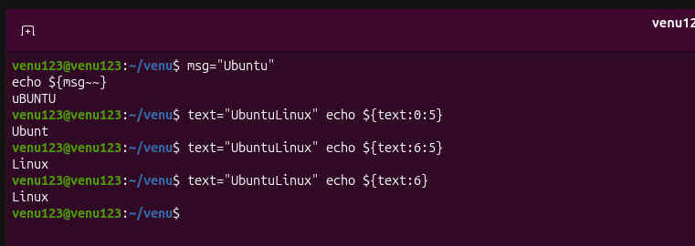
. Count the occurrences of a specific pattern in a file
To count every single occurrence of a specific pattern in a file on Linux Ubuntu—even if the pattern appears multiple times on the same line—use the command: grep -o 'pattern' filename | wc -l. []
The standard -c flag in grep only counts the number of lines that contain a match which will give you an incorrect total if a line has multiple instances. [ ]
. Count All Total Occurrences (Including Multi-matches Per Line)
The -o flag forces grep to output only the matched parts placing each individual match on its own separate line. Piping that output into wc -l then counts the total number of lines. [ ]

grep -o 'your_pattern' filename.txt | wc -l

- Example: If you want to count how many times the word "error" appears in a log file execute: grep -o 'error' var/log/syslog | wc -l.
. Count Only the Number of Matching Lines
If your goal is to count how many lines contain the pattern at least once use the built-in -c flag from grep: [ ]

grep -c 'your_pattern' filename.txt

. Advanced Counting Scenarios
Depending on what you are filtering for you can append additional flags to refine your pattern extraction: []
- Case-Insensitive Match: Add the -i flag to catch both lowercase and uppercase variations (e.g. matching "Error" "ERROR" and "error").

grep -io 'pattern' filename.txt | wc -l

[ ]
- Exact Whole-Word Match: Add the -w flag to prevent matching substrings (e.g. matching the standalone word "log" but ignoring "logger" or "clog").

grep -wo 'pattern' filename.txt | wc -l

[ ]
- Regex Pattern Match: Add the -E flag if your pattern uses extended regular expressions (like matching a sequence of numbers or special wildcards).

grep -Eo '[-]{}-[-]{}-[-]{}' filename.txt | wc -l


. Sort lines based on a specific field or column
To sort lines based on a specific field or column in Linux Ubuntu use the sort command with the -k (key) flag followed by the column number. By default the command assumes columns are separated by whitespace (spaces or tabs). [ ]
. Default Whitespace Delimiter
If your text fields are separated by spaces or tabs use the -k option. [ ]
- Alphabetical sort on the nd column:

sort -k filename.txt

- Numerical sort on the rd column:
(Always include the -n flag when dealing with numbers to avoid standard text sorting rules where comes before )

sort -k -n filename.txt

[ ]
. Custom Field Separator (Delimiter)
If your file uses a specific character like a comma or colon : to separate columns use the -t flag to specify that character. [ ]
- Sort a CSV file numerically by the th column:

sort -t '' -k -n filename.csv

- Sort /etc/passwd by the rd column (UID):

sort -t ':' -k -n /etc/passwd

[]
. Strict Single-Column Sorting
By default specifying -k tells Linux to sort from column all the way to the end of the line. To isolate the sort strictly to that one single column (preventing subsequent columns from acting as tie-breakers) specify the start and end fields as : [ ]

sort -k filename.txt

Useful Variations
- Reverse the order (Descending): Add the -r flag.

sort -k -nr filename.txt

- Save the sorted output directly to a file: Use the -o flag.

sort -k filename.txt -o sorted_output.txt
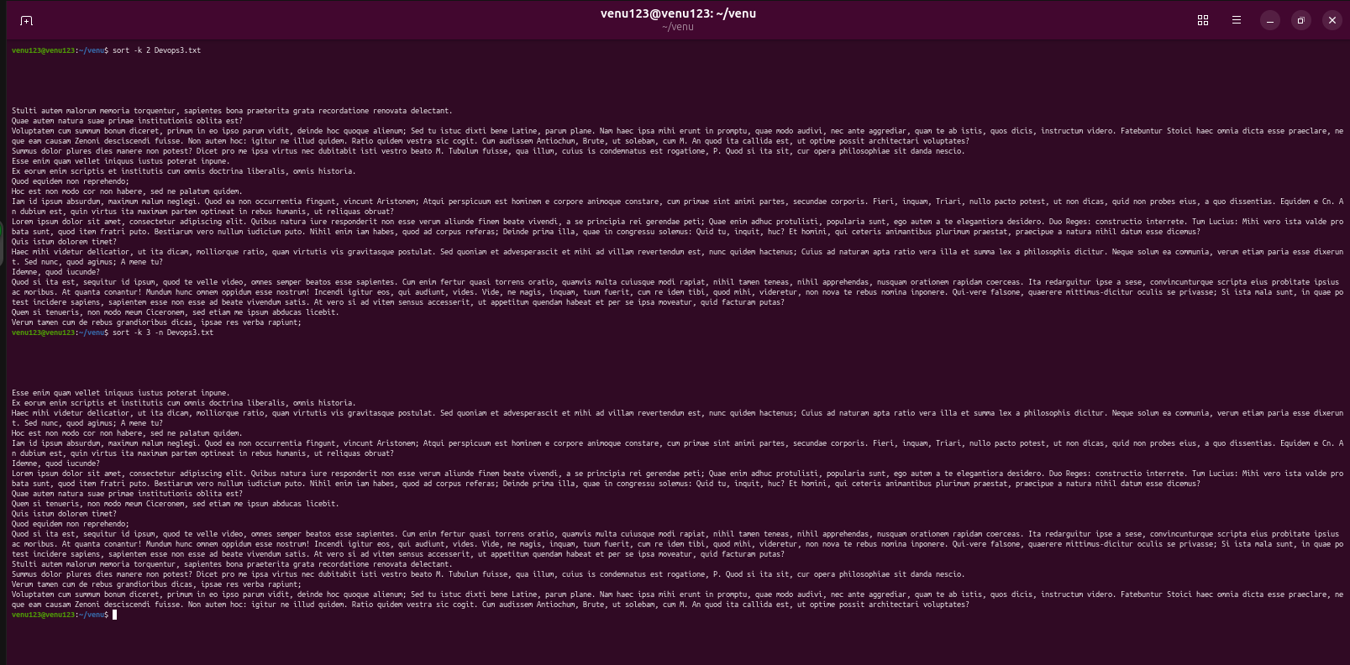

. Merge multiple files based on a common field or column
To merge multiple files based on a common field or column in Linux Ubuntu your best options are the native join command for simple structures or an awk script for scaling to three or more files seamlessly. []
The standard join command requires your files to be sorted beforehand. Here is how to achieve this using different tools. []
Method : The join Command (Best for Files)
By default the Linux join utility links lines from two files using their very first column. []
- Sort and merge files on the fly using Bash process substitution (<()):

join <(sort file.txt) <(sort file.txt) > merged.txt

- Specify non-first columns if your common fields are located elsewhere (e.g. column in file column in file):

join - - <(sort -k file.txt) <(sort -k file.txt)

- Change the delimiter (e.g. using a comma for CSV data):

join -t '' <(sort file.csv) <(sort file.csv)

- Include missing lines (Full Outer Join) so that lines without matches aren't discarded:

join -a -a -e "NULL" -o auto <(sort file.txt) <(sort file.txt)

[ ]
Method : The awk Command (Best for + Files)
The native join command can only handle two files at once. If you have multiple files an awk linear solution loads the common fields into memory effortlessly and doesn't require sorting. [ ]
Run the following command to merge an arbitrary number of files based on Column :

awk '
{ key = $; $ = "" }
NR == FNR { data[key] = $; next }
(key in data) { data[key] = data[key] $ }
END { for (k in data) print k data[k] }
' file.txt file.txt file.txt > merged_all.txt

Quick Comparison Table
Tool | Max Files | Requires Pre-Sorting? | Handles Missing Keys? | Documentation/Reference
join |  | Yes | Yes (via -a) | See GeeksforGeeks Linux join Guide
awk | Unlimited | No | Requires manual script logic | See Ask Ubuntu awk Discussions
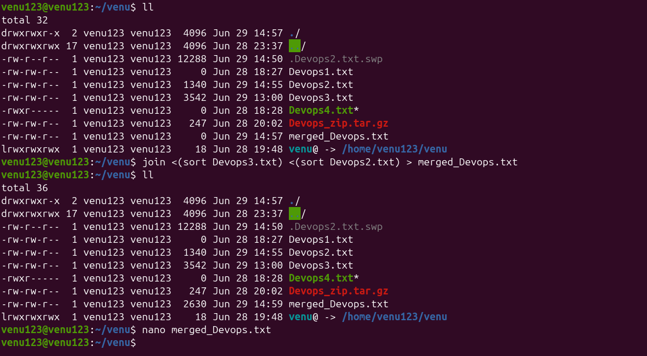

.Substitute text in a file using search and replace
To substitute text in a file on Ubuntu Linux the most powerful and common terminal tool is sed (Stream Editor). [ ]
Single File Substitution
Run the following command in your terminal to find and replace text in-place (saving changes directly to the file): [ ]

sed -i 's/old_text/new_text/g' filename.txt

Breakdown of the Command:
- -i: Edits the file in-place overwriting the original file.
- s: Specifies the substitution command.
- /: Serves as the delimiter separating your search terms.
- old_text: The string or regular expression you want to find.
- new_text: The string replacing the original text.
- g: Stands for "global" ensuring every single match on a line is replaced rather than just the first occurrence. [ ]

Useful Advanced Variations
. Safe Dry Run (Preview Changes)
Omit the -i flag to preview your replacements in the terminal output without modifying your file: []

sed 's/old_text/new_text/g' filename.txt

. Create an Automatic Backup []
To replace text but automatically save a copy of your original file before editing append an extension to the -i flag (e.g. .bak): []

sed -i.bak 's/old_text/new_text/g' filename.txt

. Case-Insensitive Search
Add the I flag at the end of the substitution block to find matches regardless of uppercase or lowercase styling: [ ]

sed -i 's/old_text/new_text/gI' filename.txt

. Handling Slashes in Paths
If your search or replace text contains forward slashes (like a web URL or a directory pathway) change the default / delimiter to an alternative character like | or : to prevent syntax errors: []

sed -i 's|/var/www/html|/home/user/public|g' filename.txt

. Replace Across Multiple Files Simultaneously []

To find and modify text across all files within your current working directory and its subdirectories combine grep with xargs: [ ]

grep -RiIl 'old_text' . | xargs sed -i 's/old_text/new_text/g'

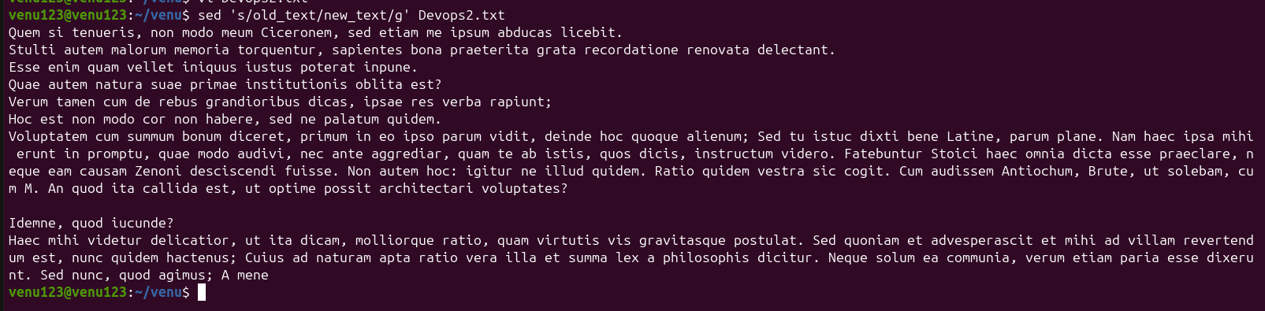

. Set up a Application Server (e.g.Apache Tomcat);

To set up an Apache Tomcat application server you must fulfill the primary prerequisite of installing the Java Development Kit (JDK) before extracting and configuring the Tomcat files.
This comprehensive guide covers the manual setup process which works across Windows Linux and macOS platforms. [ ]

. Install Java (Prerequisite)
Tomcat is a Java-based servlet container and requires a valid Java environment to compile and execute web applications. [ ]
- Windows/macOS: Download and run the installer from the Oracle Java SE Downloads page or use OpenJDK.
- Linux (Ubuntu/Debian): Run the following commands in your terminal to update repositories and install the package:

sudo apt update
sudo apt install default-jdk

- Verify Installation: Confirm your installation by running java -version in your terminal or command prompt.

. Download Apache Tomcat
Get the core distribution files from the official source. [ ]
- Go to the Apache Tomcat Official Website. []
- Select a stable version from the left navigation pane (e.g. Tomcat or Tomcat ). [ ]
- Under the Binary Distributions section look for Core:
  - Windows: Download the -bit/-bit Windows Service Installer (executable wizard) or the .zip archive.
  - Linux/macOS: Download the .tar.gz archive. [ ]

. Extract and Organize Files
If you downloaded an archive instead of using the Windows executable setup installer unpack it manually: [ ]
- Extract Archive: Unzip or untar the downloaded files into your preferred directory (e.g. C:\tomcat\ on Windows or /opt/tomcat/ on Linux). [ ]
- Directory Overview: Inside the root folder you will interact with these core directories:
  - bin/: Contains startup shutdown and management scripts.
  - conf/: Contains global server configuration files like server.xml.
  - webapps/: The deployment directory where your application files (.war) live.
  - logs/: Holds server console output and error logs. [ ]

. Configure Environment Variables
The application server needs explicit paths to locate your Java runtime environment and its own home folder. [ ]
On Windows:
- Search for Environment Variables in the Windows Start menu. []
- Under System Variables click New and add:
  - Variable name: JAVA_HOME
  - Variable value: C:\Program Files\Java\jdk-xx (Your exact JDK path) [ ]
- Create another variable:
  - Variable name: CATALINA_HOME
  - Variable value: C:\tomcat (Your exact Tomcat installation folder) [ ]
On Linux/macOS:
Open your shell configuration file (e.g. ~/.rc or ~/.zshrc) or create a setenv.sh inside Tomcat's bin directory then append the paths: [ ]

export JAVA_HOME=/usr/lib/jvm/default-java
export CATALINA_HOME=/opt/tomcat

. Configure Manager GUI Credentials (Optional)
To access the web-based management dashboard you must declare an administrator account in the configuration. [ ]
- Open conf/tomcat-users.xml in a text editor.
- Add the following block right above the closing </tomcat-users> tag:
xml
<role rolename="manager-gui"/>
<role rolename="admin-gui"/>
<user username="admin" password="YourSecurePassword" roles="manager-guiadmin-gui"/>

[ ]
(Note: If accessing the manager dashboard from a remote machine you must also comment out the Valve IP address restrictions found inside the webapps/manager/META-INF/context.xml file). []

. Start the Server and Verify
Execute the initialization scripts to launch your application server instance. []
- Windows: Open a Command Prompt inside the Tomcat bin folder and run startup.bat.
- Linux/macOS: Open a Terminal inside the Tomcat bin folder grant execution permissions if needed (chmod +x *.sh) and run ./startup.sh.
- Verify: Open your browser and navigate to http://localhost:. If successful the Tomcat welcome landing page will load. [ ]

. Deploy Applications
When you are ready to serve code use one of these default approaches: [ ]
- Direct Webapps Deployment: Drop your compiled Web Application Archive (.war) file directly into the webapps/ folder. Tomcat automatically unzips and deploys it on the fly.
- Manager App Upload: Access the web console dashboard at http://localhost:/manager/html and upload your .war archive directly through the management user interface

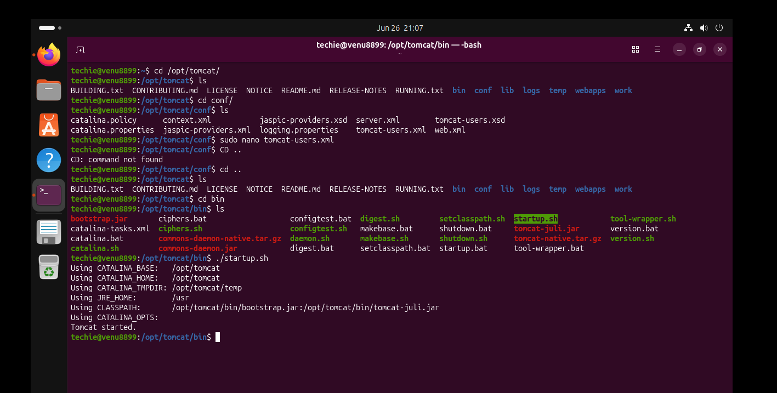

. Delete specific lines based on a pattern or line number
To delete specific lines based on a pattern or line number in Linux Ubuntu the most effective tool to use is sed (Stream Editor). By default sed prints the modified output to the terminal; to modify the file directly you must use the -i (in-place) flag. [ ]
. Deleting by Line Number
You can target singular lines exact ranges or custom selections. [ ]
- Delete a specific single line (e.g. line ):

sed -i 'd' filename.txt

- Delete a range of lines (e.g. lines through ):

sed -i 'd' filename.txt

- Delete multiple separate lines (e.g. lines and ):

sed -i 'd; d; d' filename.txt

- Delete the first line:

sed -i 'd' filename.txt

- Delete the last line:

sed -i '$d' filename.txt

- Delete everything from a specific line to the end (e.g. line to the end):

sed -i '$d' filename.txt

[ ]
. Deleting by Pattern
You can target lines that match specific text strings or conditions. [ ]
- Delete lines containing a specific keyword:

sed -i '/keyword/d' filename.txt

- Delete lines that do NOT contain a keyword (inverted match):

sed -i '/keyword/!d' filename.txt

- Delete lines starting with a specific word:

sed -i '/^keyword/d' filename.txt

- Delete completely empty lines:

sed -i '/^$/d' filename.txt

- Delete empty lines including those filled with spaces/tabs:

sed -i '/^[[:space:]]*$/d' filename.txt

[ ]
. Mixing Patterns and Line Numbers
You can combine line numbers and regex patterns for complex extractions. [ ]
- Delete from a specific line number to a matching pattern (e.g. line through the first occurrence of "error"):

sed -i '/error/d' filename.txt

- Delete lines matching a pattern only within a specific range (e.g. delete "debug" only between lines and ):

sed -i '{/debug/d}' filename.txt

[ ]
💡 Safe Testing Tip
Before running an in-place modification that directly alters your dataset omit the -i flag to inspect the output safely in your terminal: [ ]

sed 'd' filename.txt

Alternatively back up your data dynamically during execution by attaching a file extension to the -i flag (e.g. -i.bak): [ ]

sed -i.bak '/error/d' filename.txt

(This edits filename.txt and automatically creates an untouched copy named filename.txt.bak.)

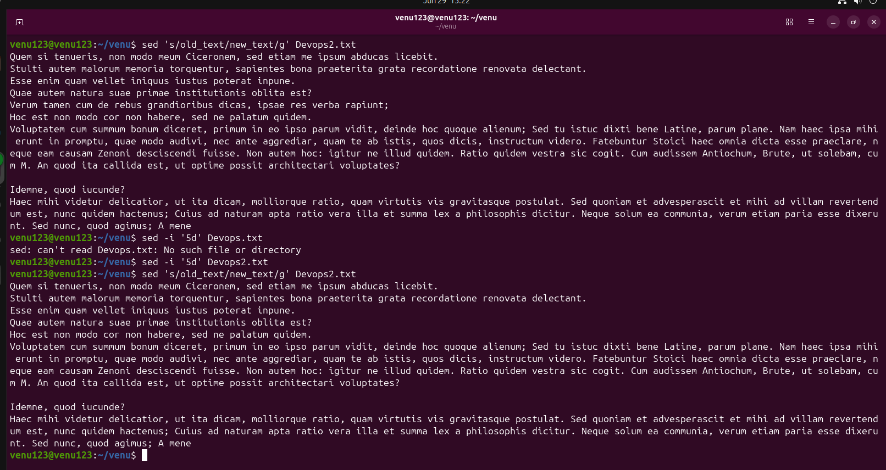

. Append or insert text before or after a specific pattern or line
To insert or append lines relative to a specific pattern in Linux Ubuntu the sed (stream editor) command is the most powerful tool. You can target files directly by including the -i flag to save changes in place or omit it to safely preview your changes in the terminal. [ ]

. Insert a New Line Before a Pattern
To place a completely new line above a matching line use the i (insert) command. [ ]

sed -i '/TARGET_PATTERN/i \YOUR_NEW_LINE' filename.txt

- Example: To insert "Hello World" right before the line containing "Ubuntu" run:
sed -i '/Ubuntu/i \Hello World' file.txt
. Append a New Line After a Pattern
To place a completely new line below a matching line use the a (append) command. [ ]

sed -i '/TARGET_PATTERN/a \YOUR_NEW_LINE' filename.txt

- Example: To add a line after a configuration match see how this logic applies in discussions on Tecmint.
. Insert Text inside the Same Line (Before a Word)
If you want to inject text into the exact same line right before your pattern rather than adding a whole new line use the substitute (s) command combined with an ampersand (&) to represent the matched text. [ ]

sed -i 's/TARGET_PATTERN/NEW_TEXT&/g' filename.txt

- Example: To turn "I love Linux" into "I love Ubuntu Linux" search for "Linux" and prepend "Ubuntu ":
sed -i 's/Linux/Ubuntu &/g' file.txt
. Append Text inside the Same Line (After a Word)
To inject text directly after a pattern on the same line place the new text after the ampersand (&). []

sed -i 's/TARGET_PATTERN/&NEW_TEXT/g' filename.txt

- Example: To turn "Version " into "Version ." run:
sed -i 's/Version /&./g' file.txt
. Targeting Specific Line Numbers
If you do not have a text pattern but know the exact line number replace the /PATTERN/ block with the line number. [ ]
- Insert before line : sed -i 'i \New text line' file.txt
- Append after line : sed -i 'a \New text line' file.txt [ ]

Quick Syntax Breakdown
- -i : Modifies the file in-place (saves changes).
- a : Appends a line below.
- i : Inserts a line above.
- s : Substitutes text on the same line.
- & : Special character that recalls whatever matched your search pattern.

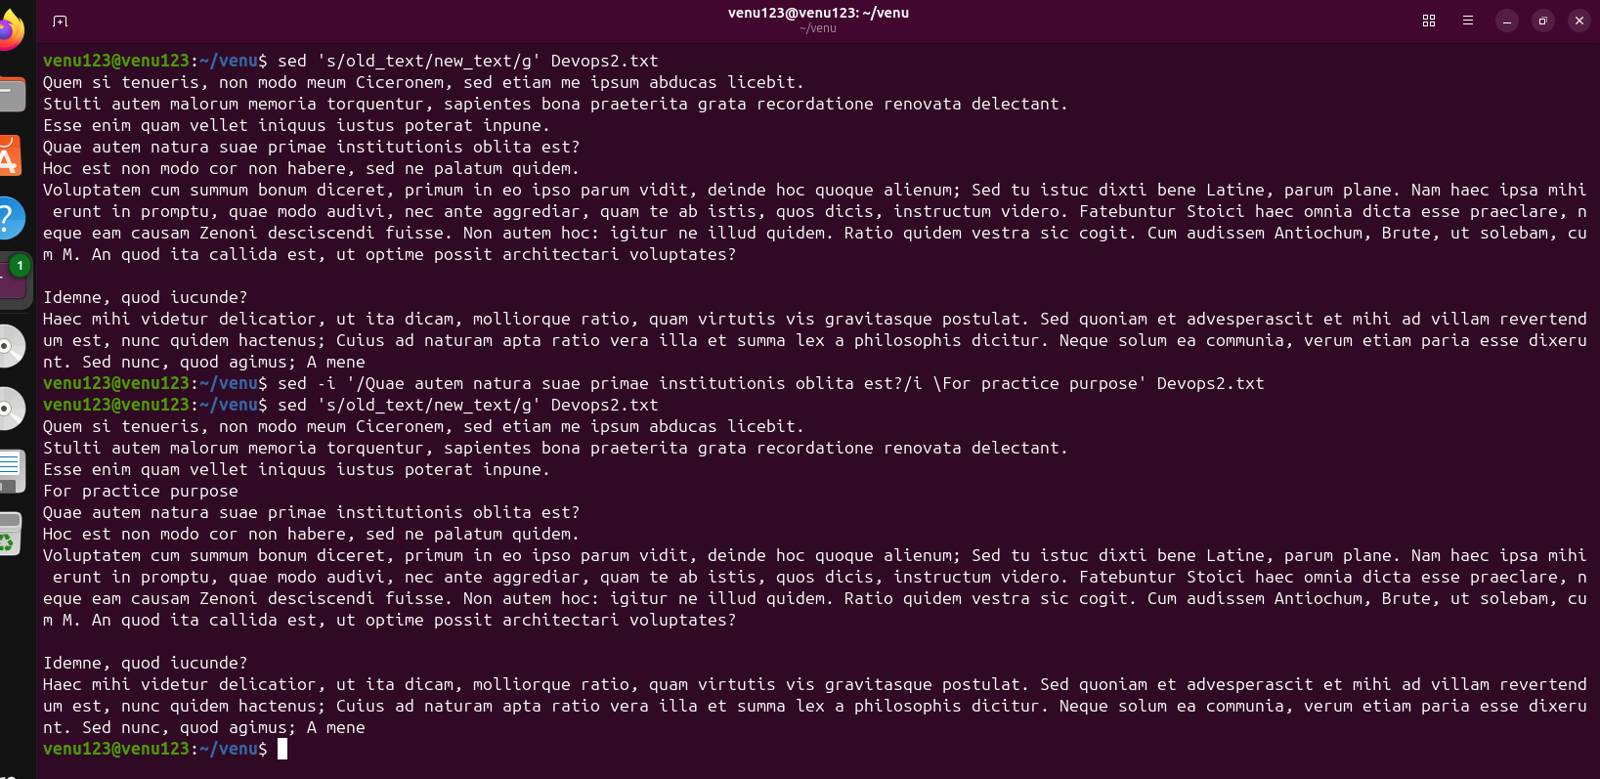
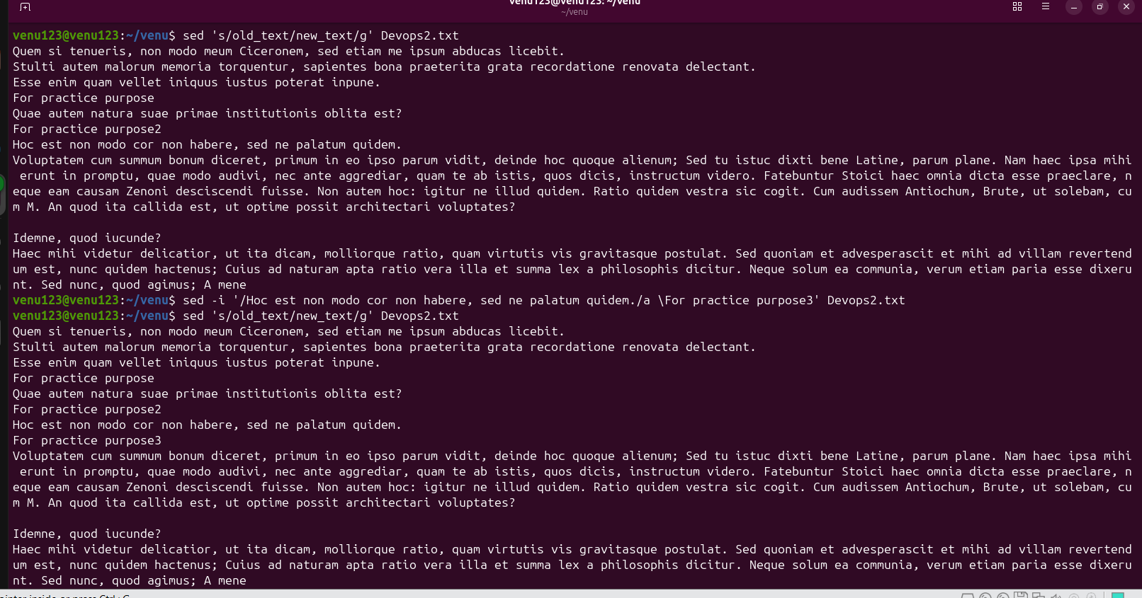

.Print only specific lines from a file:
To print specific lines from a file in Linux Ubuntu the most efficient and standard tool to use is the sed command. It targets exact line numbers without loading the whole file into terminal memory. [ ]
Here is how you can print exactly what you need based on different use cases.
📌 Print a Single Specific Line
To print only line of a file use the -n flag to suppress default output and the p flag to print the targeted line: [ ]

sed -n 'p' filename.txt

📌 Print a Continuous Range of Lines
To print everything from line to line (inclusive): []

sed -n 'p' filename.txt

📌 Print Multiple Disconnected Lines
To target completely separate lines (e.g. lines and ) separate your commands with a semicolon:
sed -n 'p;p;p' filename.txt

📌 Alternative Methods
Depending on your preference or layout requirements you can also use these common Linux tools:
- Using awk: Great for logic conditions. To print line :

awk 'NR==' filename.txt

- Using head and tail: Best for smaller files when you want a quick workaround. To get line extract the first lines then grab the last one:
head -n filename.txt | tail -n
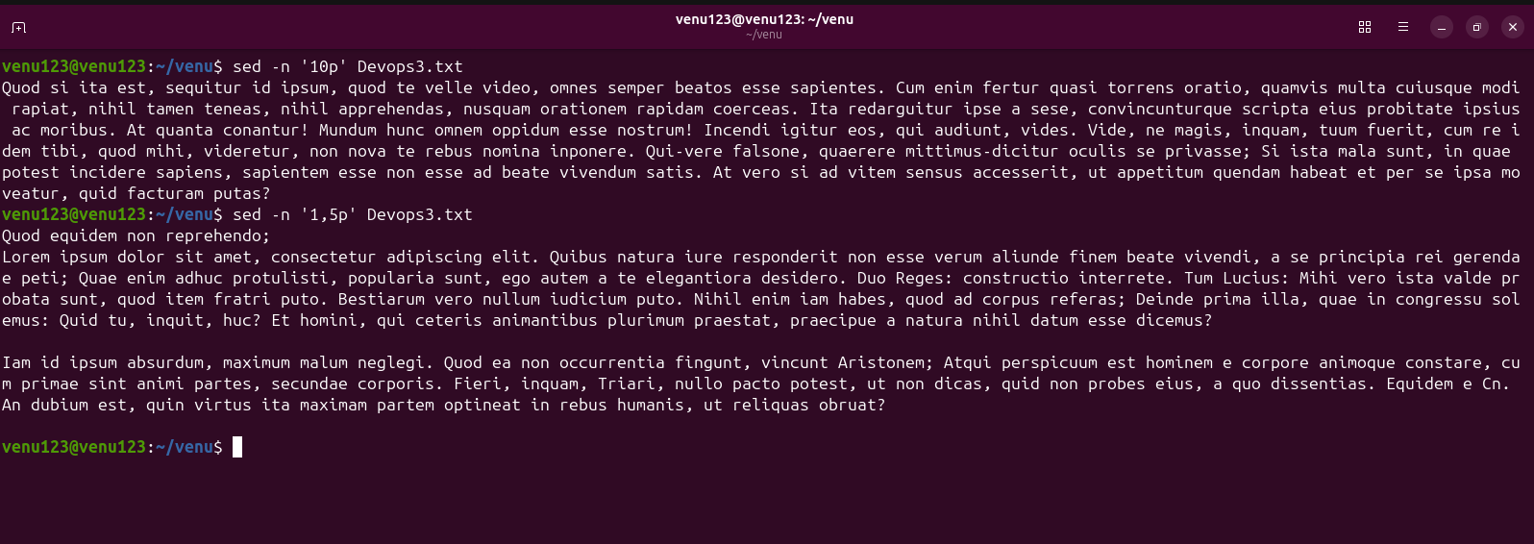
. Copy file from linux to windows machine
The most efficient way to copy a file from an Ubuntu Linux machine to a Windows machine is by using the native scp (Secure Copy Protocol) command or a graphical SFTP client. [ ]
Method : Push from Ubuntu using Terminal (Requires Windows OpenSSH)
Windows and have a built-in OpenSSH server that allows you to push files directly from your Ubuntu terminal. [ ]
- Enable SSH on Windows: Open Settings > Apps > Optional Features. Ensure OpenSSH Server is installed and running.
- Find Windows IP: Open Command Prompt on Windows type ipconfig and note your IPv Address.
- Run the Command: Open your Ubuntu terminal and execute the OpenSSH scp command:

scp /path/to/ubuntu/file.txt windows_user@windows_ip:"C:/Users/YourName/Desktop/"

  - Note: Keep the quotes around the Windows destination path to handle backslashes or spaces cleanly.
Method : Pull from Windows using Terminal (Easiest CLI Method)
Instead of fighting with Windows firewall permissions from Ubuntu it is often simpler to open the Windows command line and pull the file from Ubuntu. Ubuntu has SSH enabled by default in most environment instances. [ ]
- Find Ubuntu IP: In your Ubuntu terminal run hostname -I.
- Run the Command: Open PowerShell or Command Prompt on Windows and run this scp syntax:
powershell
scp ubuntu_user@ubuntu_ip:/path/to/ubuntu/file.txt "C:\Users\YourName\Desktop\"

Method : Drag-and-Drop Graphical Tools (No Commands)
If you prefer a visual user interface you can manage the transfer entirely from your Windows machine without typing paths. []
- WinSCP: Download and open WinSCP on Windows. Enter your Ubuntu IP username and password. Your Windows directories will show on the left panel and your Ubuntu files will show on the right. Simply drag the file across. [ ]
- FileZilla: Download FileZilla Client on Windows. Use the Quickconnect bar with sftp://your_ubuntu_ip along with your Ubuntu login credentials to transfer folders visually.

. use cases for AWK and use cases for sed
AWK and sed are complementary Linux text-processing tools: AWK focuses on structured data and column-based analysis while sed excels at stream editing and line-by-line transformations. Think of awk as a data analyst for tables or logs and sed as an automated find-and-replace mechanism for files. [ ]
Here are distinct real-world use cases for each tool complete with brief explanations and practical examples.

Use Cases for awk
AWK treats a text file as a collection of fields and records making it ideal for processing tables system metrics and logs. [ ]
- Extracting specific data columns
Pulls specific fields out of structured outputs using any delimiter like spaces or colons.
ls -l | awk '{print $ $}' (Prints only the file size and filename from directory listings) [ ]
- Filtering logs by time or conditions
Parses application log files to filter data based on numeric thresholds or text patterns.
awk '$ >= ' /var/log/nginx/access.log (Finds all server entries returning -level HTTP error codes) [ ]
- Performing math calculations on text data
Aggregates numbers dynamically directly from the shell without needing a spreadsheet program.
ps aux | awk '{sum+=$} END {print "Total CPU:" sum}' (Calculates total real-time CPU usage across all system processes) [ ]
- Formatting text reports
Rearranges extracted data into clean padded human-readable layouts using structured formatting variables.
awk -F: '{printf "%-s %s\n" $ $}' /etc/passwd (Creates an aligned table of system usernames and their home directories) [ ]
- Finding duplicate lines across columns
Tracks item counts within specific fields to discover unique or repeating patterns.
awk '{count[$]++} END {for (word in count) print word count[word]}' file.txt (Counts how many times each distinct word appears in a file) [ ]

Use Cases for sed
Sed is a stream editor built to search replace insert or delete lines of text natively across configuration files. [ ]
- Automating global find-and-replace transformations
Swaps targeted text patterns across files in bulk using the substitution flag.
sed -i 's/localhost/.../g' config.yaml (Silently modifies the system config file to overwrite all hostnames globally) [ ]
- Cleaning up log file lines
Slashes bloat or sensitive data out of data streams using targeted pattern deletions.
sed '/DEBUG/d' application.log (Removes every log entry containing a debug tag before exporting) [ ]
- Modifying lines within specific ranges
Edits configurations or text blocks strictly restricted to numbered bounds.
sed 's/HTTPS/HTTP/g' web.conf (Replaces terms exclusively within the first lines of the file) [ ]
- Injecting lines into config templates
Inserts critical text definitions exactly before or after structural anchors.
sed '/\[database\]/a host=localhost' app.ini (Finds the database header block and appends a line below it) [ ]
- Printing isolated snippet windows
Extracts specific lines by suppressing default output and selectively triggering a print operation.
sed -n 'p' system.log (Grabs and displays lines through of a massive log file)
